Voyages of Discovery

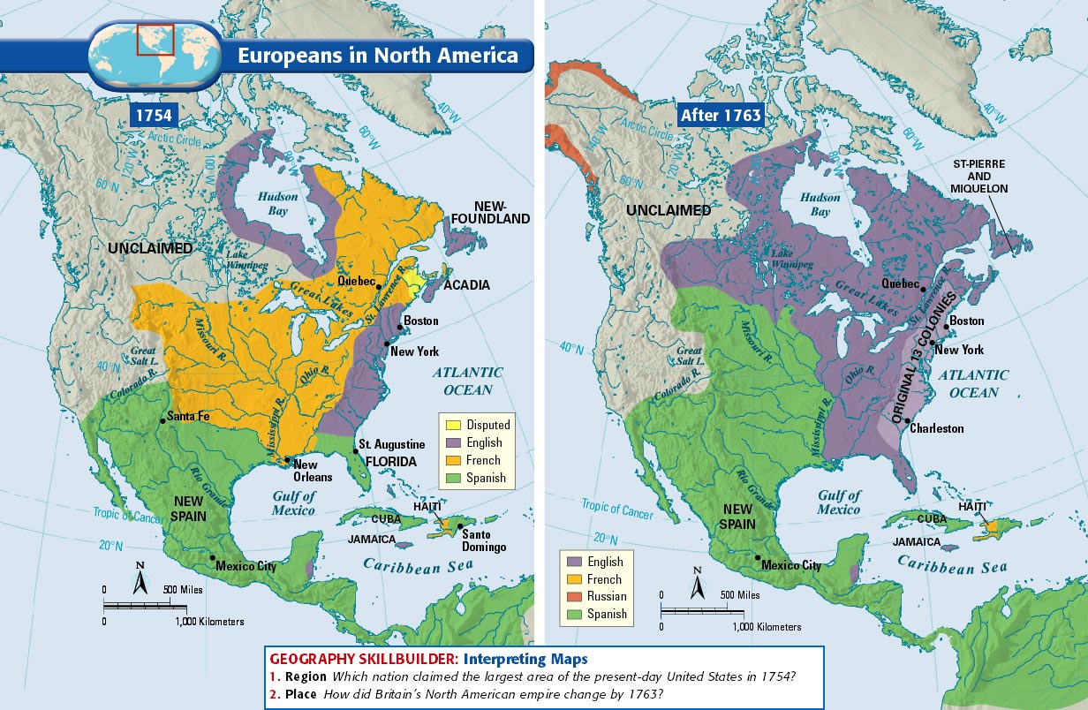

**Portuguese: First to launch**

1. What did Prince Henry do to foster exploration?

2. What was his ultimate goal?

3. Who sailed for them?

**How did the following technological advances help the voyages of discovery?**

Compass (China)

Astrolabe (Muslims)

Caravel

Patrons: People who sponsored the trips. Who were the main rulers who sponsored trips?

**Spanish**

1. What was the goal of the Spanish rulers in sponsoring exploration?

2. Who sailed for them?

**English, French, and Dutch**

1. What were the main reasons for their attempts at exploration?

2. Who sailed for them?

What were the reasons behind the voyages of exploration?