Why Limit Slavery Only in the Territories?  The Free Soil Party argued that slavery should not expand into the territories. Senator Jefferson Davis questioned the new party’s motives. Why would they only try to limit slavery in the territories but not in the states? Rather than true concern for the slaves, Davis believed they had another purpose. | “It is not humanity that influences you…It is that you may have an opportunity of cheating [the South] that you want to limit slave territory…it is that you may have a majority in the Congress of the United States and convert the Government into an engine of northern aggrandizement. It is that your section may grow in power and prosperity upon treasures unjustly taken from the South…[Y]ou want…to promote the industry of the New England states, at the expense of the people of the South and their industry.”—Senator Jefferson Davis of Mississippi | 1A. What did Davis claim was the Free-Soil Party’s true motivation for banning slavery in the new territories?
Slavery and the Union  By the time Congress debated the Compromise of 1850, white Boston abolitionist William Lloyd Garrison had been protesting against slavery for more than two decades and a growing number of Americans were joining his cause. He stated his resistance to compromise clearly: | “I am for union!...[but] I am not for SLAVERY and UNION. ..[T]his is the issue we make before the country and the world”—William Lloyd Garrison, 1850 | 2A. Why were abolitionists such as William Lloyd Garrison unhappy with the Compromise of 1850?
A House Divided  In the election of 1858, Abraham Lincoln and Stephen A. Douglas competed to represent the state of Illinois in the US Senate. In a series of debates that captured the nation’s attention, they argued about slavery. Douglas supported poplar sovereignty as the way to resolve the slavery crisis. Lincoln, while not so certain of a solution, believed that the nation could not continue to exist half slave and half free. Lincoln kicked off his campaign with a speech summarizing his position: | “A house divided against itself cannot stand. I believe this government cannot endure permanently half slave and half free. I do not expect the Union to be dissolved—I do not expect the house to fall—but I do expect it will cease to be divided. It will become all one thing, or all the other.”—Abraham Lincoln, June 16, 1858 | 3A. What is Lincoln’s position on slavery?
The President Falters:  Outgoing President James Buchanan condemned South Carolina’s secession from the Union but was unwilling to use force to stop it. Many northerners criticized his weak response to the crisis. In an address to Congress, he seemed almost baffled that the situation had deteriorated so far: | “How easy it would be for the American people to settle the slavery question forever and to restore peace and harmony to this distracted country!...All that is necessary to accomplish the object, and all for which the slave States have ever contended, is to be let alone and permitted to manage their domestic institutions in their own way. As sovereign States, they, and they alone, are responsible before God and the world for the slavery existing among them”—President Buchanan, December 3, 1860 | 4A. How did President Buchanan believe the question of slavery should be settled?  4B. Why did many people criticize his response?

Clay’s Compromise of 1850
1. Congress would admit California as a free state
2. the people of the territories of New Mexico and Utah would decide the slavery question by popular sovereignty.
3. The slave trade—but not slavery—would be ended in Washington D.C.
4. Congress would pass a strict new fugitive slave law
5. Texas would give up its claims to New Mexico in return for $10 million.
5A. How do you think members from the North would react as opposed to members of Congress from the South?
5B. Identify which parts of the compromise favored the North and which favored the South.
5C. What did Calhoun threaten?

Should the Union Be Saved?
The settling of the West made it impossible to maintain equal numbers of free and slave states. Western territories wanted to become free states. The argument over California statehood showed how the North and South were moving toward a civil war.
John Calhoun  Calhoun, from South Carolina, was a passionate supporter of slavery. As a senator, he argued that any state had the right to secede, or leave the Union, if it disagreed with national laws.  “[T]here is not a single Territory n progress in the Southern section, and no certainty that any additional State will be added to it. [This destruction of the equilibrium] was caused by the legislation of this government, which was appointed as the common agent of all…  If you admit [California] under all the difficulties that oppose her admission, you compel us to infer that you intend to exclude [the South] from the whole of the acquired Territories, with the intention of destroying…the equilibrium between the two sections”—Senator John Calhoun, March 4, 1850 | Daniel Webster  Webster, from Massachusetts, was a strong nationalist. As a senator, he supported sectional compromise as a way to preserve the Union.  “I wish to speak to-day, not as a Massachusetts man, nor as a Northern man, but as an American and a member of the Senate of the United States. I speak to-day for the preservation of the Union. ‘Hear me for my cause.’ I speak to-day out of a solicitous and anxious heart, for the restoration to the country of that quiet and that harmony which make the blessings of this Union so rich, and so dear to us all.  [T]he strength of America will be in the Valley of the Mississippi. [What can we] say about the possibility of cutting that river in two? I would rather hear of war, pestilence, and famine, than to hear talk of secession…[T]o dismember this glorious country!...No Sir!”—Senator Daniel Webster, March 7, 1850
Compare
6A. What does Webster mean when he says “the strength of America will be in the Valley of the Mississippi”? What would cut the Mississippi River in two?
6B. What does Calhoun accuse the US government of doing?

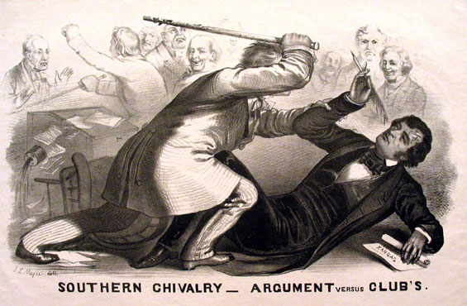
Violence in the Senate—Representative Brooks beat Senator Sumner with a cane meant to train dogs.
7A. What does this depiction tell you about the event?
7B. What do you think the fight was about?
Uncle Tom’s Cabin by Harriet Beecher Stowe
In Harriet Beecher Stowe’s controversial story, a kind Kentucky slave owner is forced by financial necessity to sell his slave, Tom. Tom remains kind and gentle, despite losing his family and ending up in the possession of a cruel man named Simon Legree. The story led many early readers to think of slaves as people, rather than as possessions, for the first time. In this excerpt, Tom is sold to Legree at an auction.
Various spectators, intending to purchase, or not intending as the case might be, gathered around the group, handling, examining, and commenting on their various points and faces with the same freedom that a set of jockeys discuss the merits of a horse.

Tom had been standing wistfully examining the multitude of faces thronging around him, for one whom he would wish to call master. And if you should ever be under the necessity, sir, of selecting, out of two hundred men, oen who was to become your absolute owner and disposer, you would, perhaps, realize, just as Tom did, how few there were that you would feel at all comfortable in being made over too…

A little before the sale commenced, a short, broad, muscular man…elbowed his way through the crowd, like one who is going actively into business; and, coming up to the group, began to examine them systematically. From the moment that Tom saw him approaching, he felt an immediate and revolting horror at him, that increased as he came near. He was evidently, though short, of gigantic strength. His round, bullet head…and stiff, wiry, sunburned hari, were rather unprepossessing items…This man proceeded to a very free personal examination of the lot. He seized Tom by the jaw, and pulled open his mouth to inspect his teeth; made him strip up his sleeve, to show his muscle; turned him round, made him jump and spring to show his paces...

Tom stepped upon the block, gave a few anxious looks round; all seemed mingled in a common, indistinct notice, the clatter of the sales man crying off his qualifications in French and English, the quick fire of French and English bids; and almost in a moment came the final thump of the hammer, and the clear ring of the last syllable of the word “dollars,” as the auctioneer announced his price, and Tom was made over. –He had a master!

He was pushed from the block;--the short, bullet-headed man seizing him roughly by the shoulder, pushed him to one side, saying in a harsh voice, “Stand there, you!”
Thinking Critically
8A. Identify Point of View: Whose point of view is reflected in this selection?
8B. Demonstrate Reasoned Judgment: How accurately could a white northern woman portray the feelings of an enslaved person being auctioned? What parts of her story might have been written differently by someone who had been enslaved?
8C. How might northerners and southerners have differed in their opinions of Uncle Tom’s Cabin?

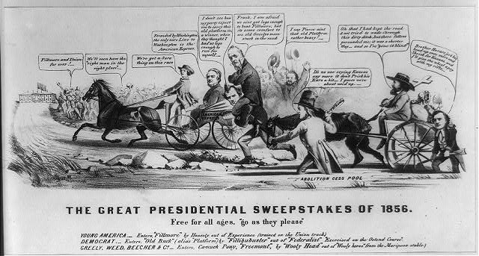
Analyzing Political Cartoons
A Race for the Presidency—In this cartoon, the Know-Nothing candidate Fillmore leads the race in the “American Express” carriage, which represents his anti-immigrant platform. The outgoing Democratic Republican Fremont is last, urged on by the abolitionist Horace Greeley (wearing a top hat).
9A. Explain the cartoonist’s stance on abolition.
9B. Did the cartoonist correctly predict the election results?
“The Union was established n the right of each State to do as it pleased on the question of slavery, and every other question.”—Stephen A. Douglas, 1868  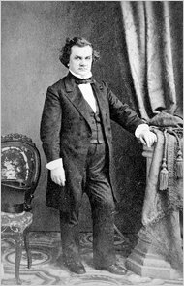 | 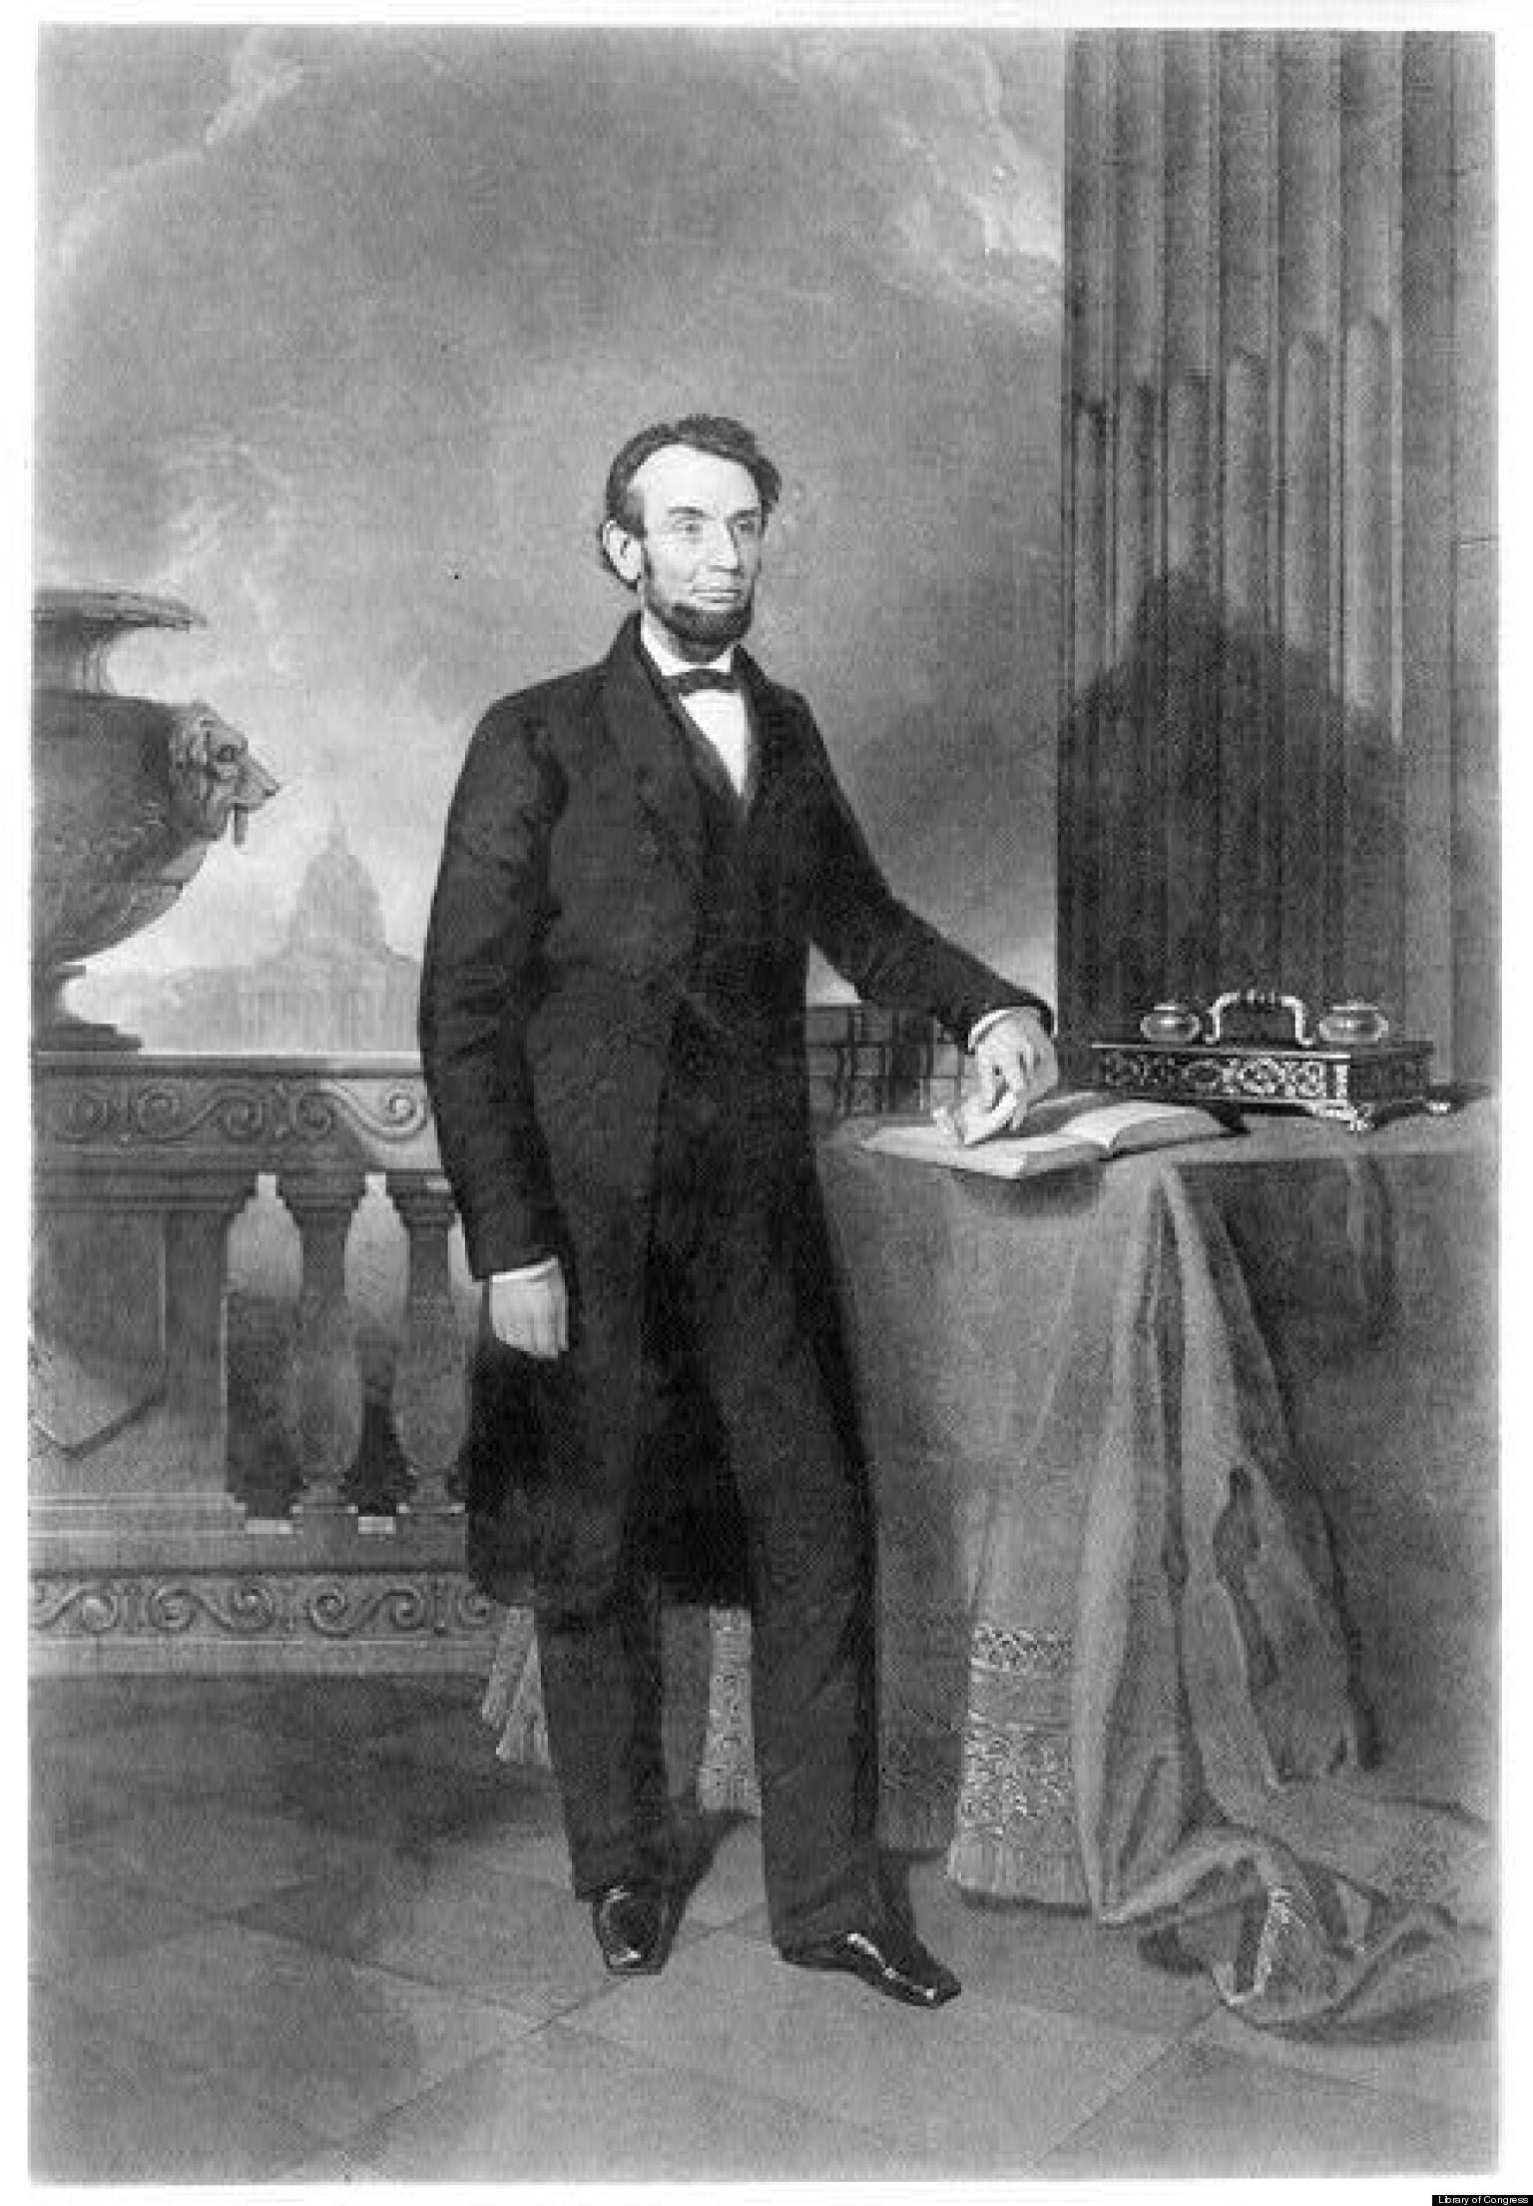  “There is no reason in the world why the negro is not entitled to all the natural rights enumerated in the Declaration of Independence—the right of life, liberty, and the pursuit of happiness. I hold that he is as much entitled to these as the white man…In the right to eat the bread, without the leave of anybody else, which his own hand earns, he is my equal and the equal of Judge Douglas, and the equal of every living man.”—Abraham Lincoln, 1858

10A. Why did Douglas support popular sovereignty?
10B. In what way was Lincoln’s loss of the 1858 election considered a victory? (your thoughts)
10C. Look at the visuals, describe what each image shows about the candidates.
B: Hurry up Douglas! And get the door open, so that I can get in; for the watch man is coming.
C: Confound it! None of these Keys will unlock this door so I’d better be off, for old Abe is after me with a sharp stick.
D. I’ll do all I can to help you Breck, but my strength is failing and I’m afraid you’ll pull me out before I can pull you in.
E: Ah, M Buck! I’m too weak to get up and we shall be compelled to dissolve the Union.
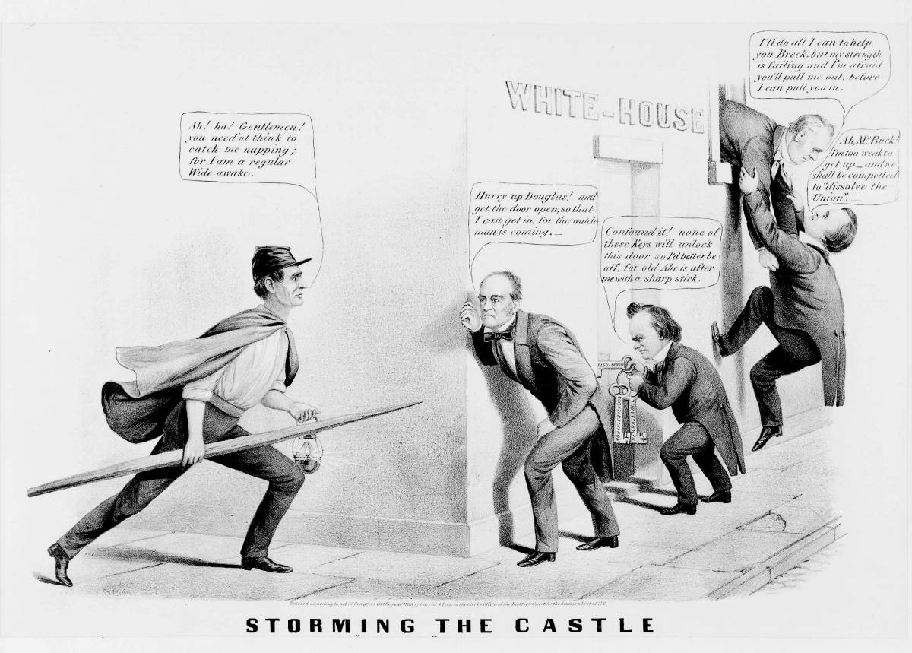
D
Ah! Ha! Gentlemen! You nee’nt think to catch me napping for I am a regular wide awake!
C
B
E
The election of 1860 was a turning point for the US. Look at the cartoon above to see one viewpoint of the campaign for the presidency. Try to figure out what the cartoonist thinks of each of these candidates. Lincoln is on the left, dressed as a member of a Republican support group called the “Wide Awakes”. As he approaches the White house, the other candidates try to sneak in.
John Bell tells Stephen Douglas to hurry up. Douglas, meanwhile, tries to unlock the door with different keys, but none of them works. In the far right, the current President, Buchanan, tries to pull John Breckinridge in through the window.
Thinking Critically
C
B
Ah! Ha! Gentlemen! You need’nt think to catch me napping; for I am a regular Wide awake
11A. What is the meaning of the keys with which Douglas is trying to open the door?
11B. How is Lincoln portrayed in a different manner from the other candidates?

