Topic/Intro | Quote | Questions
Marching Off to War  When the war began, families on both sides watched as husbands and sons rushed to join the Union and Confederate armies. Often there were celebratory parades to cheer the soldiers on. As the men marched off, family members felt both sadness and pride. One Richmond resident noted these mixed emotions in her diary: | “An old lady, the mother of several dearly lobed sons, but echoed the almost universal sentiment when she said…’War, I know is very dreadful, but if by the raising of my finger, I could prevent my sons from doing their duty to their country now, though I love them as my life, I could not do it. I am no coward nor have I brought up my boys to be cowards. They must go if their country needs them’”—Sallie Brock Putnam, Richmond during the War | 1A. What is the southern mother’s attitude toward the war?
A Memorable Day  Frederick Douglass, the foremost African American abolitionist, journalist, and orator of his time, traveled the US and spoke out against slavery. In his autobiography, he described his reaction to the Emancipation Proclamation: | “The first of January, 1863, was a memorable day in the progress of American liberty and civilization. It was the turning point in the conflict between freedom and slavery. A death blow was then given to the slave holding rebellion. Until then the federal arm had been more than tolerant to hat relic of barbarism…We fought the rebellion, but not its cause. And now, on this day…the formal and solemn announcement was made that thereafter the government would be found on the side of emancipation. This proclamation changed everything”—Frederick Douglass, Life and Times of Frederick Douglass | 2A. What does Douglass say the Union has been fighting to this point?  2B. What does he think the Union should be fighting?  2C. How does the proclamation change the war?
The Hardships of War  Mrs. Judith Brockenbrough McGuire, the wife of a high school principal from Alexandria, Virginia, kept a diary that describes daily life in the South under siege highlights the hardships endured by her friends and neighbors as Union soldiers confiscated the supplies they so desperately needed: | “February 11, 1863. For ten days past I have been at the bedside of my patient in Richmond. The physicians for the third time despaired of his life; by the goodness of God have is again [recovering his health]. Our wounded are suffering excessively for tonics, and I believe that many valuable lives are lost for the want of a few bottles of [medicine]…Oh, how cruel it is that the Northern Government should have made medicines and the necessaries of life to the sick and wounded, contraband articles!”-Judith Brockenbrough McGuire, Civil War Diary | 3A. What kinds of supplies are especially needed in the South?  3B. Why are there a shortage of these goods in the South?
Gettysburg: A Soldiers Story  In early July 1863, North and South clashed near Gettysburg, Pennsylvania. A young Union officer described the fighting on a hill called Little Round Top: | “As we reached the crest a never to be forgotten scene burst upon us. A great basin lay before us full of smoke and fire and literally swarming with rider less horses and fighting, fleeing and pursuing men. The air was saturated with the sulphor fumes of battle and was ringing with the shouts and groans of the combatants. The wild cries of charging lines, the rattle of musketry, the booming of artillery and the shrieks of the wounded were the orchestral accompaniments of a scene like very hell itself…”—Lt. Porter Farley, 140th New York Infantry Regiment | 4A. What does Farley’s description tell you about what it is like to be on the battlefield?
The South Surrenders  Confederate General John B. Gordon was with General Lee at Appomattox Court House when the army of Northern Virginia surrendered to Union troops. Gordon later described the despair of his soldiers: | “During these last scenes at Appomattox some of the Confederates were so depressed in spirit…that the future seemed to them shrouded in gloom. They knew that burnt homes and fenceless farms, poverty and ashes, would greet them on their return from the war. Even if the administration at Washington should be friendly, they did not believe that the Southern States could recover in half a century from the chaotic condition in which the war hd left them.”—General John B. Gordon, Reminiscences of the Civil War | 5A. Why did the future seem so bleak to Confederate soldiers returning home after the war?

New Technology Changes Warfare
The Civil War revolutionized warfare. On water, new warships steamed into battle encased in thick armor plating. On land, the minie ball and the repeating rifle greatly improved soldiers’ accuracy and firepower in battle. These changes resulted in staggering numbers of casualties on both sides. As the conflict dragged on, military commanders were forced to change their strategies to account for the deadly impact of new technology

Wooden Ships were no match for ironclads like the Confederate Virginia and the Union Monitor  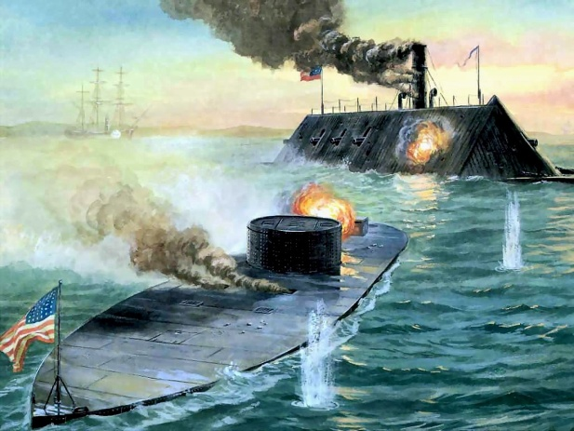 | Cone shaped minie balls were accurate at much greater ranges than round bullets.  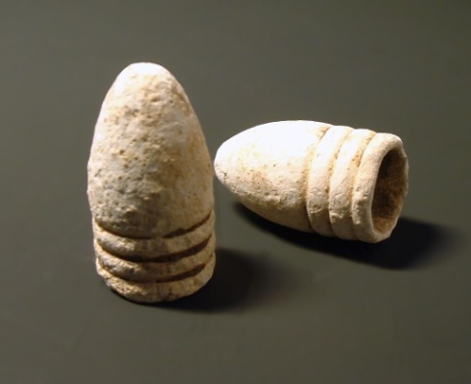 | This Henry repeating rifle could be fired 16 times before reloading.  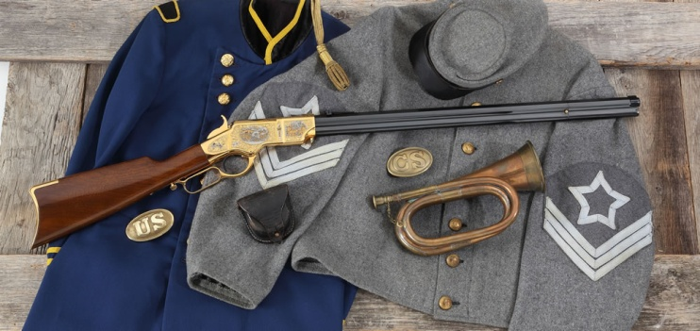
Most Civil War troops were arranged into tightly packed formations prior to marching against an enemy position. New firearms and ammunition exacted a gruesome toll on the massed attackers.  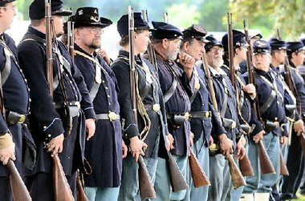 | As Casualties mounted, soldiers adapted their tactics and dug trenches for cover from enemy fire.  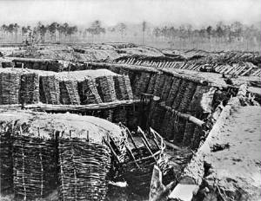 | Thinking Critically:  6. Compare and Contrast: How did Civil War technology differ from earlier military technology?  7. Draw Conclusions: How might future military tactics change because of lessons learned during the Civil War?

Antietam: The Bloodiest Day of the War
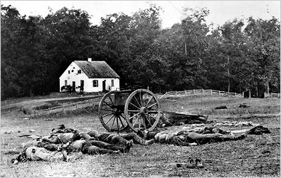 | Casualties at Antietam  Union Confederate  Phase of the Battle Troops Involved Casualties* Troops Involved Casualties*  Morning 22,400 6,550 20,800 6,050  Midday 9,700 2,900 6,500 2,600  Afternoon 13,820 2,350 6,000 1,120  *Casualties include troops injured, captured, missing, or killed  Source: National Park Service

The gruesome clash at Antietam claimed thousands of lives. Above, Confederate dead lie near the Dunker Church. Though the Union lost more men during the battle, Confederate losses amounted to a higher percentage of troop strength.
8. What does the photograph tell you that the information in the table does not?
9. What do the numbers in the table tell you that the photograph does not?

Songs of the Civil War
Soldiers on both sides loved music during the war, from the rousing marching tunes they sang to summon courage in battle to the sentimental campfire songs that longed for the day “When This Cruel War is Over.” However, North and South each embraced its own anthem that lived the spirits of soldiers fighting in the field.

The Battle Hymn of the Republic  When abolitionists and poet Julia Ward Howe visited Washington, D.C., in 1861, she heard Union troops sing a marching song called “John Brown’s Body.” Later that night, the stirring tune still ringing in her ears, Howe composed lyrics she believed were better suited to the noble cause of ending slavery. The first time Abraham Lincoln heard “The Battle Hymn of the Republic,” he stood up, tears running down his face, and called out over the cheering crowd: “Sing it again! Sing it again!” | Mine eyes have seen the  Glory of the coming of  The Lord;  He is trampling out the  Vintage where the  Grapes of wrath are stored;  He hath loosed the fateful  lightening of His terrible  swift sword;  His truth is marching on.  Glory, glory, hallelujah! (3x)  His truth is marching on
Dixie  The song that came to represent the South was actually written by a northern musician named Daniel Decatur Emmett in 1859. The origin of the song’s title is uncertain—possibly it came from the Mason-Dixon line that separated North and South—but homesick Confederate soldiers took the tune as their own. When the war ended in 1865, Lincoln ended a celebratory address to a crowd outside the White House by asking a nearby band to play “Dixie”. | Oh, I wish I was in the land  Of cotton  Cinnamon seed and sandy bottom,  Look away, look away, look away Dixie Land.  In Dixie Land, where I was born in,  Early on one frosty mornrin’,  Look away, look away, look away Dixie Land.  I wish I was in Dixie, Hooray! Hooray!  In Dixie Land I’ll take my stand  To live and die in Dixie  Away, away, away down south in Dixie  Away, away, away down south in Dixie
Thinking Critically
10. Analyze Lyrics: Why do you think Union soldiers found the “The Battle Hymn of the Republic” so inspiring?
11. Draw Inferences: Why might Lincoln have asked for “Dixie” to be played when the war ended?

Source: Civil War Solider whose leg was amputated on the battlefield in
1864.

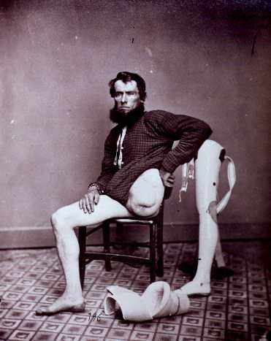

Questions to Consider:
- What does this tell you about medicine during and after the Civil War?
- Does this represent a positive or negative change in the United States? Why?

