Test #2: Civil War Study Guide
*Answer the following questions to help you review the information for your test. Remember, if you complete all of the questions in Part A BEFORE the test, you will receive bonus points.

PART A
- What was President Lincoln’s justification for going to war?
- What role did enslaved African’s in the South play during the war?
- Name the advantages of the Union and the advantages of the Confederacy prior to the war.
"If I could save the Union without freeing any slave I would do it, and if I could do it by freeing all the slaves I would do it; and if I could do it by freeing some and leaving others alone, I would do that."– Abraham Lincoln, 1862
- The quotation illustrates Lincoln’s attempt do what?
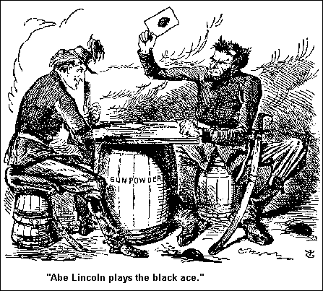

- This cartoon, published in the British magazine Punch in January of 1863, is referring to what?
- One major reason Lincoln cast the “black ace” into his card game with Jefferson Davis was that he hoped to do what?
- How did the Civil War affect the Northern economy?
- Explain the policy of conscription. Why was it put in place?
- Describe the Anaconda Plan.
- Why did John Wilkes Booth shoot Abraham Lincoln?
- Why did the North win the Civil War?
- Describe the effects of the Civil War (both positive and negative).
PART B ON BACK -

PART B
There will also be review questions on the test. Any question from the last test has the potential to be on this test. Please review the questions from the study guide for Test #1 listed below to help you.
- Define “sectionalism.” What is causing sectionalism in the US at this time?
- What is the Missouri Compromise? The Compromise of 1850? How do they differ?
- What is the Freeport Doctrine? What happens as a result?
- “A house divided against itself cannot stand”--what issue was Lincoln referring to?
- Why did Lincoln justify fighting a Civil War?
- Why did sectional differences develop in the US?
- Who is Dred Scott? What did he do? What was the result of his case?
- Who is John Brown? What is he known for?
- Explain the purpose of the Underground Railroad.
- Why did slavery expand in the South and not in the North?
- What is the Fugitive Slave Law? What are the different provisions?
- What happens once Lincoln is elected?

