Name____________________________________________________________Date________________
Unit 2: After the Middle Passage: Latin America
The Selling of Africans
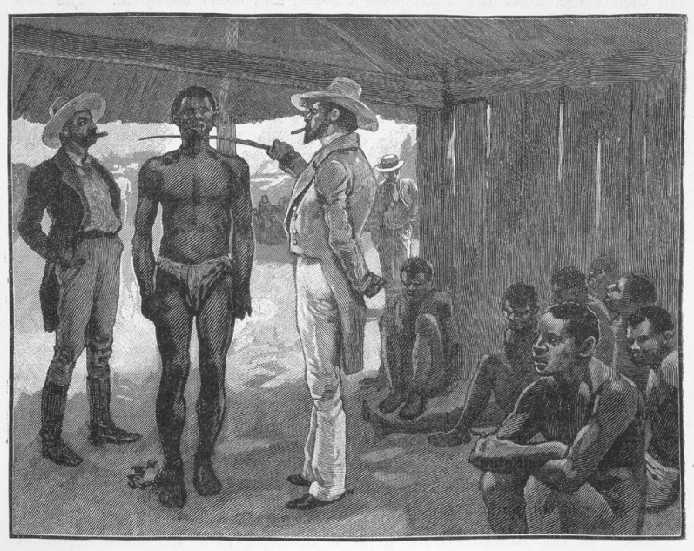
As slave ships neared their Caribbean destinations, the crew prepared the human cargo for landing and sale. They allowed the slaves to shave, wash with fresh water, and take more vigorous exercise. Those bound for the larger Caribbean islands or for the British colonies of southern North America were often given some weeks to rest on dry land before moving to their final destination. The process of landing and sale that ended the middle passage was often as protracted (drawn out and long) as the events that began it in Africa. After anchoring at a small island, slave captains negotiated with the agents of local planters over numbers and prices. They then determined whether to sell all their slaves at their first port, sell some of them, or sail to another island or port.
Often, slave captains and crew members had to do more to prepare slaves for sale than allow them to clean themselves and exercise. The ravages of cruelty, confinement, and disease could not be easily remedied. According to legend, young African men and women arrived in the Americas with gray hair, and captains used dye to hide such indications of age before the slaves went to market. Slaves were also required to oil their bodies to conceal blemishes, rashes, and bruises.
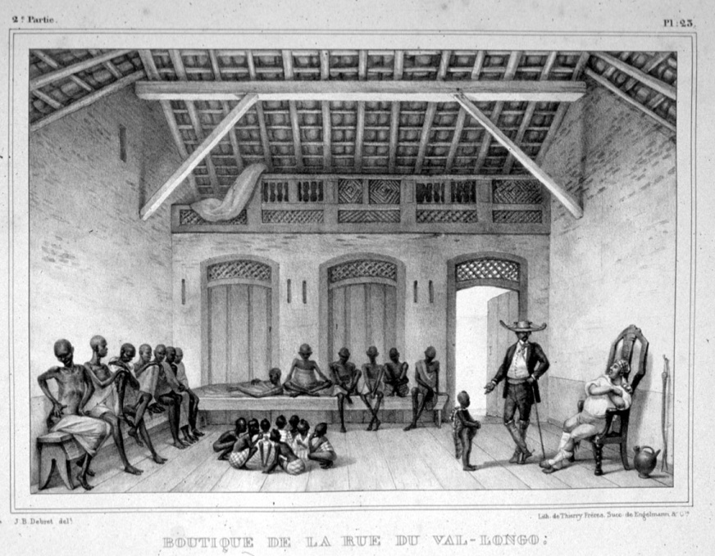
The humiliation continued as the slaves went to market. Once again they suffered close physical inspection from potential buyers, which—according to Olaudah Equiano –caused “much dread and trembling among us” and “bitter cries.” Unless a single purchaser agreed to buy an entire cargo of slaves, auctions took place either on deck or in sale yards on shore. However, some captains employed “the scramble.” In these barbaric spectacles, the captain established standard prices for men, women, and children, herded the Africans together in a corral, and then allowed buyers to grab as many slaves as they wanted.
1) How did the middle passage affect the physical bodies of the enslaved Africans? Why did slave traders help them look better?

2) How do you think the middle passage affected the mental health of those who survived?

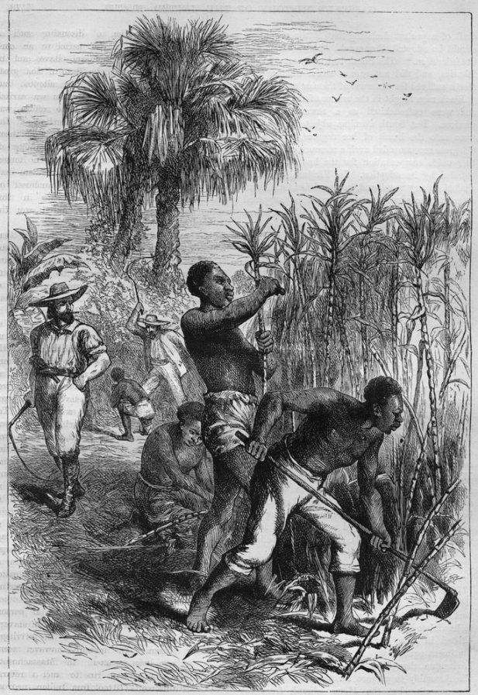
Seasoning
After buying the enslaved Africans, the planters divided the slaves into three categories: Creoles, slaves born in the Americas; old Africans, slaves who had lived in the Americas for some time; and new Africans, those who had just survived the middle passage. For resale, Creole slaves were worth three times the value of unseasoned new Africans or old Africans.
White slave owners began the process of making new Africans more like Creoles. In the Caribbean, this process involved teaching them how to work on sugar plantations. A plantation is a large farm where slaves worked. This education was also a means of preparing many slaves for resale to planters, who preferred “seasoned” slaves to “unbroken” ones who came directly from Africa. Seasoning was a disciplinary process intended to modify the behavior and attitude of slaves and make them effective laborers. As part of this process, the slaves’ new masters gave them new names: Christian names, generic African names, or names from classical Greece and Rome like Jupiter, Achilles, or Plato. Slave owners also branded slaves with their initials, marking that the slaves now belonged to them.

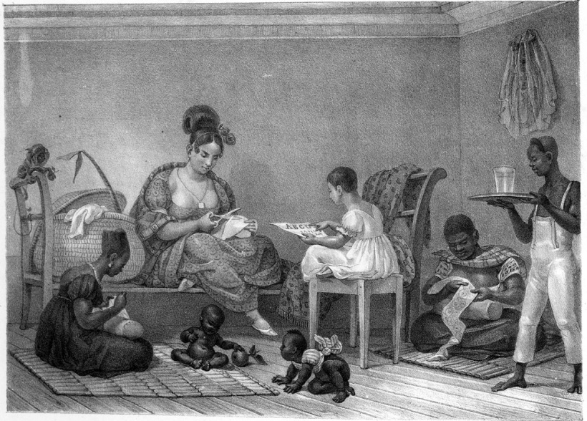
The seasoning process also involved slaves learning European languages. Masters on the Spanish islands of the Caribbean were especially thorough in this regard. Consequently, the Spanish language of African slaves and their descendants, although retaining some African words, was easily understood by any Spanish-speaking person. In the French and English Caribbean islands and in parts of North America, however, slave society produced Creole dialects that used grammar, vocabulary, and intonation with distinctive African linguistic features. These Africanized versions of French and English—including the Gullah dialect still prevalent on South Carolina’s sea islands and the Creole spoken today by most Haitians—were difficult for those who spoke more standardized dialects to understand.

Seasoning varied in length from place to place. Masters or overseers broke slaves into plantation work by assigning them to one of several work gangs. The strongest men joined the first gang, or great gang, which did the heavy fieldwork of planting and harvesting. The second gang, including women and old men, did lighter fieldwork, such as weeding. The third gang, composed of children, worked shorter hours and did such tasks as bringing food and water to the field gangs. Other slaves became domestic servants. New Africans served apprenticeships with old Africans from their same ethnic group or with Creoles.
3) What is seasoning?

4) What were the 3 categories that the white planters created for slaves? Which one of the categories did slave owners want?

5) What were the 4 categories of workers on the plantations?

Seasoning Continued
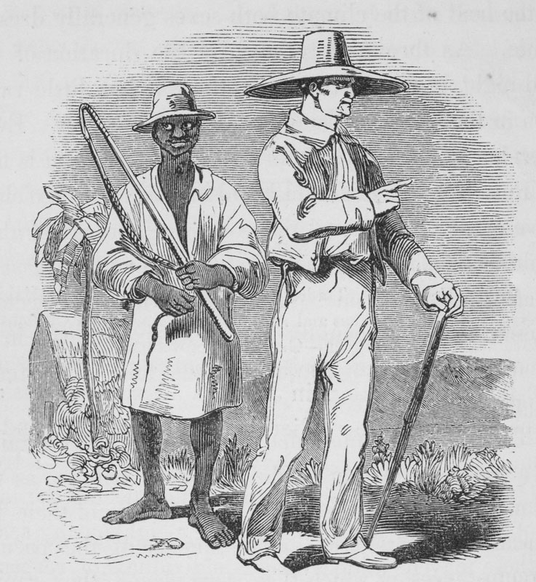
Planters had to rely on old Africans and Creoles to train new recruits because white people were a minority in the Caribbean. As a result, African custom shaped the cooperative labor of slaves in gangs. But the use of old Africans and Creoles as instructors and the appropriation of African styles of labor should not suggest leniency. Although the plantation overseers, who ran day-to-day operations, could be white, of mixed race, or black, they invariably imposed strict discipline. Drivers, who directed the work gangs, were almost always black, but they carried whips and frequently punished those who worked too slowly or showed disrespect. Planters assigned the more difficult new Africans to the strictest overseers and drivers.
Planters housed slaves undergoing seasoning with the old Africans and Creoles who were instructing them. These black instructors regarded such additions to their households as economic opportunities. The new Africans provided extra labor on the small plots of land that white planters often gave to slaves. Slaves could sell vegetables that grew from their gardens and save money to purchase freedom for themselves or others. Additional workers like the new slaves helped produce larger surpluses to sell at local markets, thereby cutting the amount of time required to accumulate a purchase price. New Africans also benefitted from this arrangement. They learned how to build houses in their new land and to cultivate vegetables to supplement the food the planter provided. Even though many Africans brought building skills and agricultural knowledge with them to the Americas, old Africans and Creoles helped teach them how to adapt to a new world.
As traumatic as the middle passage was, most Africans in the Americas had not been stripped of their memories and culture of Africa. When their ties to their villages and families were broken, they created bonds with shipmates. Such bonds became the basis of new extended families. Despite their ordeal, the Africans who survived the Atlantic slave trade and slavery in the Americas were resilient. Seasoning did modify behavior, but it did not obliterate African Americans’ cultural roots.

6) In an illustration, explain the complex relationship between the old Africans, new African, and Creoles. Answer the following questions within your image: How did old Africans and Creoles benefit from living with the new Africans? How did new Africans benefit from living with old Africans and Creoles?

The Ending of the Atlantic Slave Trade
The cruelties associated with the Atlantic slave trade contributed to its abolition in the early nineteenth century. During the late 1800s, some British people joined a movement called abolitionism, which sought to end slavery. Because the British had dominated the Atlantic trade since the early 1700s, Britain’s growing antipathy (opposition in feeling) became crucial to the trade’s destruction. But it is debatable whether moral outrage alone promoted this humanitarian effort. By the late 1700s, England’s economy was less dependent on the slave trade and the plantation system than it had been previously. To maintain its prosperity, Britain needed raw materials and markets for its manufactured goods. Slowly but surely British industrialists realized it was more profitable to invest in industry and other forms of trade and to leave Africans in Africa.
So morals and economic self-interest were combined when Great Britain abolished the Atlantic slave trade in 1807 and tried to enforce that abolition on other nations through a naval patrol off the coast of Africa. The US Congress joined Britain in outlawing the Atlantic trade the following year. Although American, Brazilian, and Spanish slavers continued to defy these prohibitions for many years, the forced migration from Africa to the Americas dropped to a tiny percentage of what it had been at its peak. Ironically, it was the coastal kingdoms of Guinea and western Central Africa that fought most fiercely to keep the trade going because their economies had become dependent on it. This persistence gave the English, French, Belgians, and Portuguese an excuse to establish colonial empires in Africa during the nineteenth century in the name of suppressing the slave trade.
7) What is abolitionism? What were the two reasons that Britain ended its slave trade? How did some African kingdoms respond to the British decision?

