Name___________________________________________Date____________________Block_________
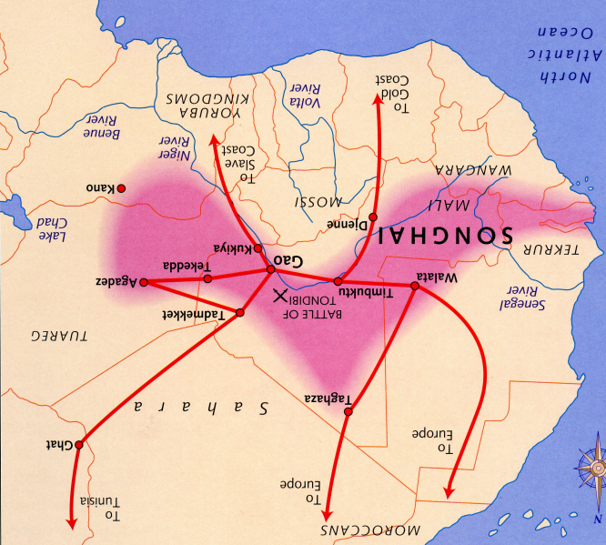
American History: The Slave Trade (Formal Grade)
The Origins of the Atlantic Slave Trade
Beginning in the 15th century (1400s), European nations explored, conquered, and colonized parts of Africa, Asia, and the Americas. Portugal took the lead in the early 1400s as ships from its ports reached Africa’s western coast. The European leaders were most interested in trading with people to gain natural resources and wealth. When Portuguese ships first arrived off the coast of Guinea, they traded for gold, ivory, and pepper, but they also wanted slaves to be their servants back in Portugal. Then, European nations created large slave-based farms, called plantations, on islands off the coast of Africa (e.g. the Canary Islands, the Cape Verde Islands, and Sao Tome). They forced slaves to work on the plantations and experimented with the plantation slavery that they would perfect in North and South America.

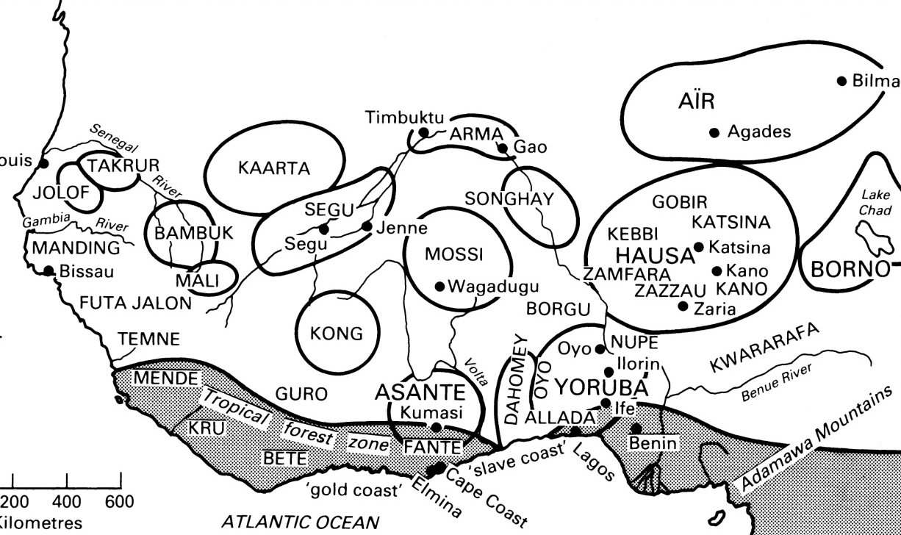
Rarely did white European people capture African slaves. Instead they purchased slaves from African traders. African rulers restricted the Europeans to a few points on the coast, rarely allowing them to enter the mainland. Then the African rulers hired their own men to buy or capture prisoners of war from villages and cities in West Africa. The Africans then sold these captured Africans to the Europeans. Although Africans were initially reluctant to sell members of their own ethnic group to Europeans, they did not consider it wrong. In fact, neither Africans nor Europeans had developed the concept of racial solidarity (unity). By the 1700s, however, many victims of the slave trade believed that such solidarity should exist. Ottobah Cugoano, who was captured and sold during that century wrote, “I must own to the shame of my countrymen that I was first kidnapped and betrayed by those of my own complexion.”
Map of West Africa in 1490
Map of West Africa in 1500

Christopher Columbus’ voyages drastically impacted the Atlantic slave trade. Columbus believed the earth to be much smaller than it actually is, and he hoped to sail west and reach Japan or India to create a new trade route to Asia. His mistake led to the European conquest, settlement, and exploitation of North and South America and the Caribbean islands, where Columbus landed. Spain, Portugal, the Netherlands, Great Britain, and France all established colonies in the “New World.” Columbus and those who followed him quickly enslaved indigenous Americans (American Indians). Immediately, large numbers of Indians died from unintentional exposure to European diseases. When the Europeans did capture Indians, they often violently revolted. Many Indians escaped slavery and easily disappeared into the wilderness that they called home for thousands of years. As the numbers of American Indians declined, Europeans relied on the Atlantic slave trade to replace them as a source of slave labor.

1) Examine the two maps above. Explain how the changes between 1490 and 1500 in West Africa could have weakened the West African resistance to the slave trade?

2) Why did European leaders want to explore the world?
3) Economically (in terms of money) why was it disadvantageous (not to your advantage) to enslave American Indians?

4) Who is more at fault for the Atlantic Slave Trade, Africans or Europeans? Explain your answer.

Growth of the Atlantic Slave Trade
As a result of the trade with Asia, Europeans were introduced to sugar. Soon Europeans were hooked on the sweet flavor, and people were willing to pay high prices for it. Europeans realized that they could grow sugar in South and Central America and sell it to Europeans for enormous profits. Sugar plantations employing slave labor spread from Brazil to the Caribbean Islands. Unlike slavery in Africa, Asia, and Europe, slavery in the Americas was based on race. In addition, most of the enslaved were males; this was due in part because most Europeans believed men were stronger laborers than women. In the Americas, enslaved Africans worked as agricultural laborers rather than soldiers or domestic servants. The enslaved also became chattel—meaning personal property—of their masters and lost their rights as human beings. Lastly, enslaved Africans and their children were more likely to be enslaved for their entire lives, rather than temporarily.
Coastal African groups traded gold and ivory with the Europeans in exchange for guns. When Europeans wanted African slaves, many of these coastal Africans began capturing Africans from rival groups to trade to the Europeans. Europeans used their knowledge of the tribes to play one leader against another or one group against another. Europeans would give an African king guns if he would raid neighboring areas to capture prisoners. When one African group had many guns, they gained great military advantage. Other groups were willing to trade with the Europeans to have the same weapons. The slave trade caused and perpetuated many wars and depopulation over four hundred years.
Portugal and Spain dominated the Atlantic slave trade during the 16th century. They shipped about two thousand Africans per year to their American colonies, with by far the most going to Brazil. During the early 17th century, the Dutch drove the Portuguese from the West Africa coast and became the principal European slave-trading nation. For the rest of that century, most Africans came to the Americas in Dutch ships—including a group of twenty in 1619 who were among the first black people to reach British North America. After a series of wars, Great Britain defeated the Dutch and took control of the Atlantic slave trade. Great Britain carried about 20,000 slaves per year from Africa to the Americas. At the peak of the trade during the 1790s, they transported 50,000 per year.

5) Use the reading to complete this chart:
African Slavery | European Slavery
List the 3 ways that most enslaved Africans became slaves:  1)  2)  3) | List the 3 European nations that controlled the Atlantic Slave Trade in order from first to last:  1)  2)  3)
What were 3 main differences between European slavery and African slavery?

1)

2)

3)

6) Explain how sugar relates to the growth of slavery in the Americas?

7) How did the European slave traders destabilize and increase war in West Africa?

Economics of the Slave Trade
The profits from the Atlantic slave trade, together with those from the sugar and tobacco produced in the Americas by slave labor, were invested in England and consequently helped fund the industrial revolution during the 18th century. In turn, Africa became a market for cheap English manufactured goods. Two triangular trade systems developed. In one, British traders carried manufactured goods like guns and exchanged them for slaves. Then they carried the slaves to the Caribbean and exchanged them for sugar, which they took back to England. In the other triangular trade, British carried rum from North America (present-day US) to West Africa to trade for slaves. From Africa they took the slaves to the Caribbean to exchange for sugar or molasses, (sugar syrup) which they took home to distill into rum.

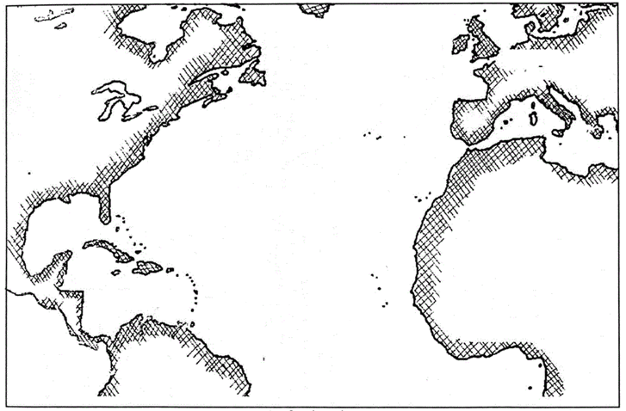
8) On this blank map, illustrate the 2 triangular trade systems:
The Capture of Africans
After the collapse of the Songhai Empire in West Africa, different groups fought one another for power. These wars resulted in many prisoners of war in West Africa when the Europeans arrived. This was significant because when the Europeans began buying more slaves, there was already a large group of temporary slaves in West Africa. Present-day Guinea and Sierra Leone became centers of the slave trade.

Europeans paid Africans to capture other Africans. Sometimes African armies enslaved the inhabitants of conquered towns and villages. At other times, raiding parties captured isolated families or kidnapped individuals. As warfare spread to the interior, captives had to march for hundreds of miles to the coast where European traders awaited them. The raiders tied the captives together with rope or secured them with wooden yokes around their necks. It was a shocking experience, and many captives died from hunger, exhaustion, and exposure during the journey. Others killed themselves rather than submit to their fate, and the captors killed those who resisted.

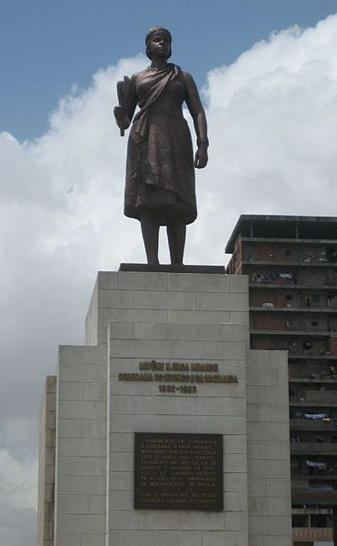
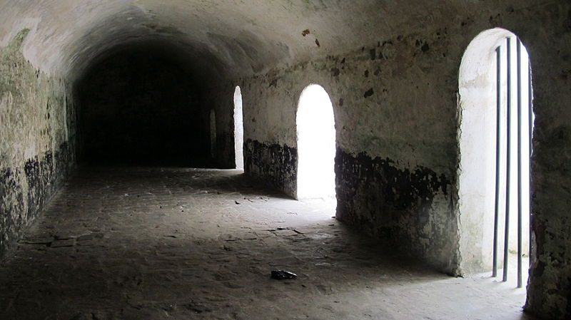
Once the captives reached the coast, those destined for the Atlantic slave trade went to fortified structures called factories. Portuguese traders constructed the first factory at Elmina on the Guinea Coast in 1481—the Dutch captured it in 1637. Such factories contained the headquarters of the white slave traders. Here they had warehouses for their trade goods and supplies and dungeons or outdoor holding pens for the enslaved Africans. In these pens, slave traders divided families and—as much as possible—ethnic groups to prevent rebellion. The traders stripped the captives naked and inspected them for disease and physical defects. Those considered fit for purchase were then branded like cattle with a hot iron bearing the symbol of a trading company.

While this minority of Africans made the slave trade possible, many others resisted the slave trade. One of the main reasons most Europeans never actually did the kidnapping was the fear of African retaliation and attack. After Portuguese leaders offered to educate young Kongo men in Europe, the Kongo leader Nzenga Meremba furiously protested the slave trade in 1526 after discovering the Portuguese had sold them into slavery. In 1644, Angolan Queen Nzinga a Mbande led armed resistance against Portuguese slave traders. In 1787, a King in Senegal prohibited any slave trade in his territory. White French slave traders confronted the king and told him to change the law and reminded him of the gifts they had recently given the king. The king returned the gifts and reminded them never to bring slaves through his territory. These small victories reduced the slave trade, but they were not strong enough to stop it entirely.

9) You are a member of the Mali tribe who was captured and enslaved in the Elmina factory. You have smuggled in a slice of paper and a pencil to write a letter and hide it in a crack in the wall of the prison cell. In your letter you must explain the following:
__ Who captured you? __ How did you get to the factory? __ What happens in the factory?
__ Will you fight back against the slave traders? Why or why not?

The Crossing
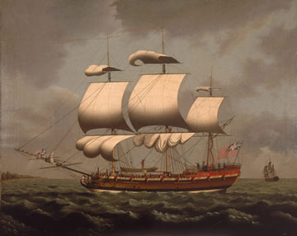
After being held in a factory for weeks or months, captives faced the frightening prospect of leaving their native land for a voyage across the ocean in European ships called slavers. This voyage became known as the middle passage. The voyage from Africa to the Americas lasted between two and three months. There were potentially disastrous natural forces such as doldrums—long windless spells at sea—and hurricanes, which could destroy ships, crews, and cargo.

The slavers (slave ships) were usually small and narrow. A ship’s size, measured in tonnage, theoretically determined how many slaves it could carry, with the formula being two slaves per ton. A large ship of three hundred tons, therefore, was expected to carry six hundred slaves. But captains ignored the formula. Some kept their human cargo light, calculating that smaller loads lowered mortality and made revolt less likely. Most captains, however, squeezed human beings together in hope that large numbers would offset increased deaths and make them more money. Ships designed to carry 450 slaves usually carried 600.
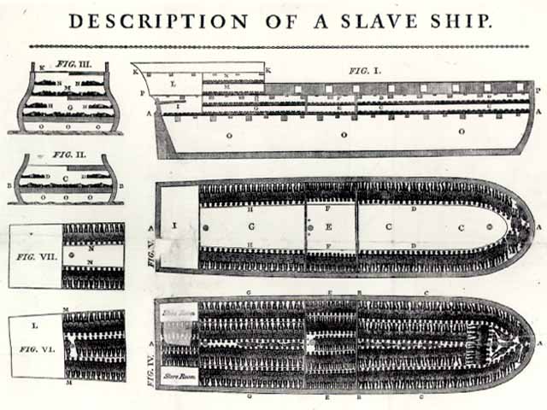
Europeans cared little about the physical and emotional damage they inflicted on enslaved Africans. The cargo space in slave ships was generally only five feet high. Ships’ carpenters halved this vertical space by building shelves, so slaves might be packed above and below on planks that measured only 5.5 feet long and 1.3 feet wide. Consequently, slaves had only about 20 to 25 inches of head room. To add to the discomfort, the crews chained male slaves together in pairs to help prevent rebellion and lodged them away from women and children. Most horrifically, the sailors abused women and took advantage of them during the voyage.
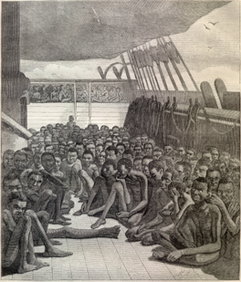
Europeans’ goal was to carry as many Africans in healthy condition to the Americas as possible in order to make large profits. Mortality (death) rates were high on slavers because the crowded, unsanitary conditions encouraged seaboard epidemics. Overall, one-third of the Africans subjected to the slave trade died between their capture and their journey on the slavers. Historians estimate that over 3,700,000 died during the Atlantic slave trade.

In 1781, a case was brought before a British court in which the captain of a slave ship was charged with throwing 132 slaves overboard. The captain was not charged with murder; the court was only called upon to decide whether the action of the captain was justified or not, and who should be responsible for the financial loss. The slave ship carried 442 slaves and was traveling from Guinea to Jamaica. Sixty of the slaves died from overcrowding. The captain, being short of water, threw ninety-six more overboard. Twenty-six more were drowned. Ten drowned themselves in despair.

10) What were these ships called?

11) What was the voyage (trip) between Africa and the Americas known as?

12) Why did slave captains ignore the formula to determine how many slaves each ship could carry?

13) How many enslaved Africans perished (died) during the slave trade?

14) Create a poster to hold during a protest against the Atlantic Slave Trade. Include a picture and a slogan (phrase)

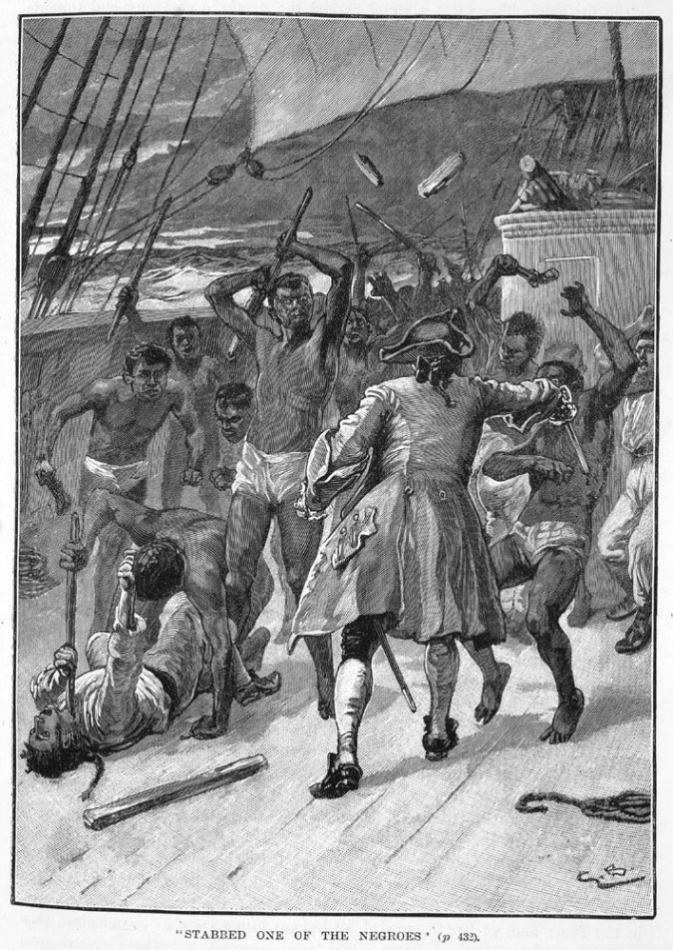
Resistance and Revolt at Sea
Because many enslaved Africans refused to accept their fate, slaver captains had to be vigilant to prevent the Africans from violently rebelling against them. Most rebellions took place while a ship prepared to set sail where the African coast was in sight, and the slaves could still hope to return home. But some revolts occurred on the open sea where it was unlikely the Africans, even if their revolt succeeded, would be able to return to their homes or regain their freedom. Both sorts of revolt indicate that not even capture, forced march to the coast, imprisonment, branding, and sale could break the spirit of many captives. These Africans preferred to face death rather than accept bondage.

Other slaves resisted their captors by drowning or starving themselves. Thomas Phillips, captain of a slave ship during the 1690s, commented, “We had about 12 negroes did willfully drown themselves and others starved themselves to death; for ‘tis their belief that when they die they return home to their own country and friends again.” To prevent slaves from starving, captains used hot coals to force individuals to open their mouths for feeding. They used nets to pull slaves out of the water when they tried to drown themselves.

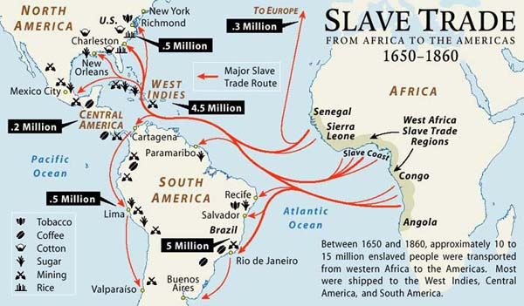

16) According to the map, which present-day African countries were most affected by the slave trade?

17) Which modern day Latin American country received the most enslaved Africans?

18) Based on the map’s key, what jobs were enslaved people forced to do in the West Indies?

19) How many enslaved Africans arrived in the present-day United States?

