Primary Source Analysis—The Reconstruction Era 1865-1877
Witness to History
Topic | Quote | Question(s)
Nothing Left But the Bare Land  Mary Chestnut was the wife of a wealthy and respected South Carolina planter and politician. During the Civil War, her husband resigned from the US Senate to fight for the Confederacy. Now, at war’s end, the family was penniless. The world they had known was gone. Mary Chesnut described the devastation. | “Mrs. Bartow drove me to our house at Mulberry. On one side of the house, every window was broken, every bell torn down, every piece of furniture destroyed, every door smashed in…[the Yankee soldiers] carried off sacks of our books and our papers, our letters were strewed along the Charleston road. Potter’s raid ruined us. He burned our mills and gins, and a hundred bales of cotton. Indeed nothing is left now but the bare land.”—Mary Boykin Chesnut, May 1865 | A. To What social or economic class did Mary Chesnut belong? How do you know?  B. Did southerners of various social classes experience the war differently?
An African American In the Senate  In 1861, Jefferson Davis left his seat in the US Senate and became President of the Confederacy. In 1870, his unfinished term was resumed by Hiram Revels—an African American. A few months later, Senator Revels stood up to make his first speech. He answered those who charged that African Americans in the South were using their new political power to seek revenge on white southerners. | “As the recognized representative of my downtrodden people, I deny the charge…They bear toward their former masters no revengeful thoughts, no hatreds, no animosities. They aim not to elevate themselves by sacrificing one single interest of their white fellow-citizens. They ask but the rights which are theirs by God’s universal law…[to] enjoy the liberties of citizenship on the same footing with their white neighbors and friends.”—Hiram Revels, speech in the US Senate, March 16, 1870 | A. In what year did Revels enter the senate, and whom did he succeed?  B. Why did Revels appeal to “God’s universal law” in his speech?
A Stormy Election  Wade Hampton was an old southern aristocrat from a long line of cotton planters and had been a Confederate general during the Civil War. In short, he was exactly the sort of man that Radical Republicans did not want to see in power. | In 1876, Hampton ran for governor of South Carolina. Across the state, huge crowds cheered his fiery speeches denouncing the carpetbaggers and scalawags who controlled the state government. Hampton won the election by a wide margin. But Radical Republicans charged fraud and refused to leave office. For four months, while federal troops barred Hampton from the statehouse, South Carolina had two separate governments. Not until the troops were withdrawn did Hampton take full possession of his office. The stormy election proved to be one of the last stands for Radical Republicans in the South. | A. Who won South Carolina’s gubernatorial election in 1876?  B. Why was the new governor unable to take office immediately after the election?

Thomas Nast
Thomas Nast (1840-1902) is considered by some to be the father of the American political cartoon. Through his drawings he attacked the major political and social issues of the post Civil War period, including corruption, economic crisis, and inequality. Initailly, political cartoons were drawn using the likeness of the subjects. However, Nast built on his skills of caricature and used this art form to clearly illustrate the intent of his imegry. In addition to his style, Nast’s influence is still reflected in the political cartoons of today, as he is creditied with poularizing such national symbols as the Democratic donkey, the Republican elephant, and Uncle Sam. | “The Brains”—1871  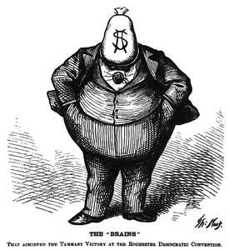  Corruption in local and national government was a major problem during the 1870s. This drawing of New York City’s Boss Tweed clearly communicates the issue. Tweed feared the power of Nast’s drawings and attempted to bribe him to stop. In the end, Nast’s cartoons were credited with Tweed’s downfall.
“Worse Than Slavery” 1874  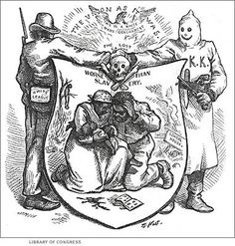  Nast was an advocate of black civil rights and drew many cartoons addressing the issue. Here he attacks the intolerable treatment of African Americans by Southern white supremacist groups. | “Out of the Ruins”—1873  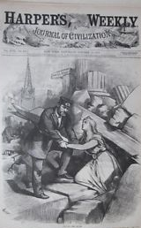  At the end of Reconstruction, the nation’s economy was very unstable. Eventually, the many financial and industrial bankruptcies led to the Panic of 1873. In this cartoon, Nast illustrates the nation’s financial crisis while alluding to a hopeful future.
Thinking Critically
1. Draw Conclusions—Why do you think a cartoon such as “The Brains” would inspire fear in a political figure?
2. Make Comparisons—How are the Nast cartoons similar to the political cartoons of today? How are they different?

The Freedmen’s Bureau
At the end of the Civil War, the federal government took on the responsibility of providing aid to 4 million emancipated slaves, as they made the transition to freedom. In 1865, the federal government established the US Bureau of Refugees, Freedmen, and Abandoned lands, which became known as the Freedmen’s Bureau. Although the Bureau was poorly funded, it was tasked with numerous responsibilities, which included providing former slaves with education nand medical care, overseeing labor contracts, and reuniting separated families. The success of the Bureau was mixed, but its greatest achievement was in education. By the time the Bureau disbanded in 1872, it had helped establish thousands of African American schools.
Freedmen’s Bureau Schools, 1865-1870  Freedmen’s Bureau spends about $5 million to set up schools for former slaves  About 250,000 students attend 4,300 Freedmen’s schools  Howard University, Hampton Institute, and Fisk University are founded and financed with the help of the Freedmen’s Bureau | The Bureau provided temporary housing such as the Freedmen’s Village in Arlington, VA where freed people could live until they found work and permanent housing  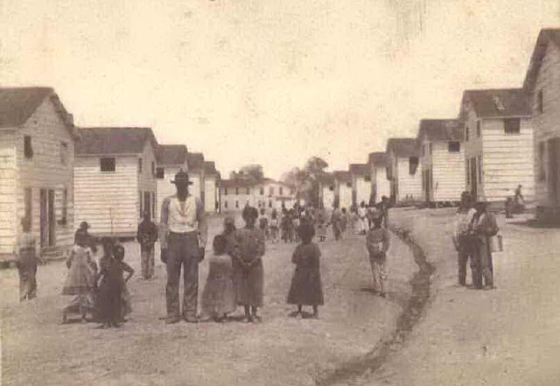
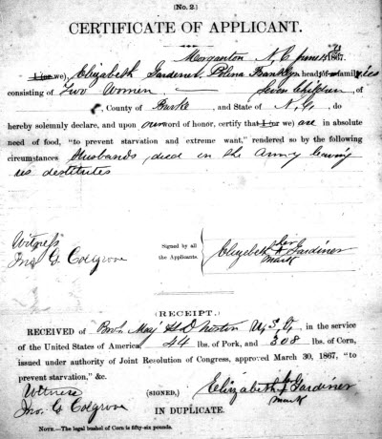  The Bureau provided certificates that legalized existing marriages and legitimized the couple’s children. Labor contracts between an employer and freedman were drawn up by the Bureau to guarantee fair treatment and wages. | Freemen schools taught freed people reading skills as well as new occupational skills.  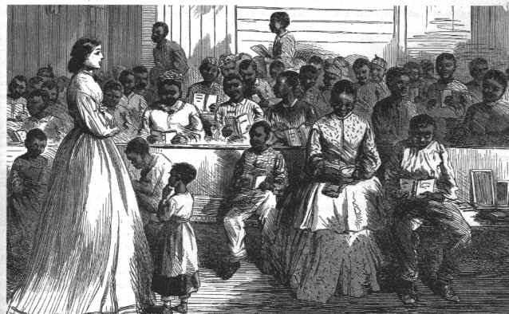
Thinking Critically
1. Identify Central Issues: Why do you think it was necessary for the federal government to provide aid to freedmen?
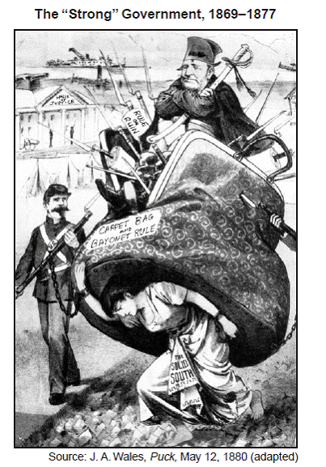
2. Determine Relevance: How would access to an education benefit newly emancipated slaves?
Analyzing Political Cartoons
- person on top: President Grant
- Union soldiers on side
- Woman on bottom represents the South
1. What do the weapons and soldiers in the cartoon represent?
2. What is the woman doing? Is her task easy or difficult?
3. What is this cartoonist’s view of Reconstruction?

Who Controls the Readmission of States?
Although their main purpose was to reunite the nation, Reconstruction policies actually created new divisions between the President and Congress. A critically divisive issue was how the southern states should be readmitted into the Union.
Johnson Opposes Tight Restrictions | Stevens Favors Tight Restrictions
As eleven states are not at this time represented in either branch of Congress, it would seem to be [the President’s] duty on all proper occasions to present their just claims to Congress…[I]f they are all excluded from Congress, if in a permanent statute they are declared not to be in full constitutional relations to the country, they may think they have cause to become a unit in feeling and sentiment against the Government—President Andrew Johnson, 1866 | The late war between two acknowledged belligerents…broke all the ties that bound them together. The future condition of the conquered power depends on the will of the conqueror…Hence a law of Congress must be passed before any new State can be admitted…Until then no member can lawfully admitted into either House…Then each House must judge whether the members…possess the requisite qualifications.—Thaddeus Stevens, 1865
You Decide
1. Why did Johnson favor immediate readmission?
2. Why did Stevens want tight restrictions?
3. What decision would you have made? Why?

