North or South:
Who Killed Reconstruction?

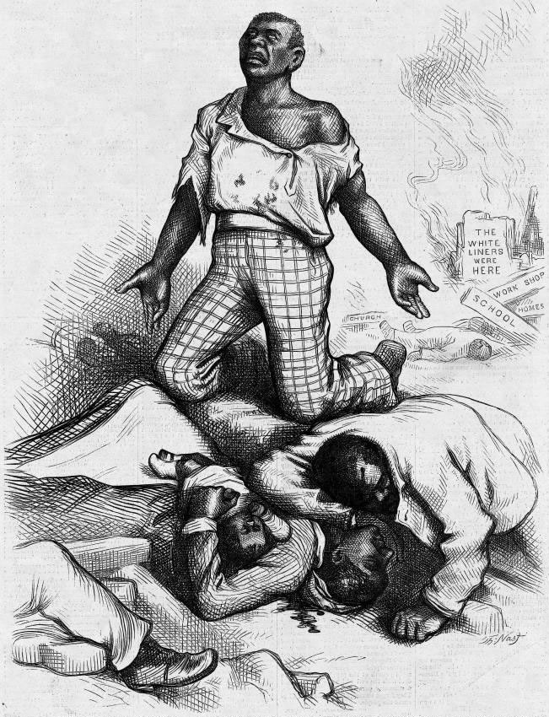
Harper’s Weekly
September 1, 1868
“Is This a Republican Form of Government?

Is This Protecting Life, Liberty, or Property?”

Overview: The twelve years after the Civil War proved to be a difficult time for America. Called Reconstruction by historians, this era saw an increase of freedom for former slaves. However, there was also great resistance to change. In 1877 attempts to reconstruct the South officially ended, leaving white-only governments in power. This DBQ asks you to decide who, North or South, was most responsible for the end of Reconstruction
Background Essay
North or South: Who Killed Reconstruction
...the slave went free; stood a brief moment in the sun; then moved back again toward slavery. -W.E.B. Dubois
1876 was an exciting year for America. It was the 100th anniversary of The Declaration of Independence and America was on the move. Homesteaders and ranchers were filling up the land west of the Mississippi River. Railroads were being built at an astounding rate. It seemed the United States was creating enough opportunity that all Americans and millions of immigrants could pursue their hopes for happiness just as Thomas Jefferson had envisioned 100 years earlier.
So it is a great irony of history that the election of 1876 officially crushed the American dream for millions of black Americans. This election saw Rutherford B. Hayes, the Republican candidate and eventual winner, square off against Samuel J. Tilden, the Democratic nominee. Although Tilden won the popular vote by a wide margin, election results in Florida, South Carolina, and Louisiana were so close that a winner could not be determined. If these three states went for Hayes, he would win the Electoral College vote and become President.
Talk of a new Civil War was in the air as the opponents in the disputed states submitted separate sets of electoral ballots. An informal agreement, now called The Compromise of 1877, avoided the crisis by granting Hayes the Presidency. In return, Hayes promised to remove the last Federal soldiers from the South, almost guaranteeing that all-white governments would rise to power. The dream of Reconstruction was officially dead.
For a while, however, it had seemed that the dream of Reconstruction might be realized. The 13th Amendment ended slavery. The 14th Amendment gave black Americans citizenship and civil rights. A Military Reconstruction Act was passed to make sure African-Americans' new rights were protected. Black churches were founded. Public schools were built for black children, and universities like Howard, Fisk, Morehouse, and Hampton were founded for black students seeking higher education. Sixteen African-Americans were elected to Congress and numerous others served at state and local levels. Finally, the 15th Amendment was ratified making it illegal to deny someone the right to vote based on race. Indeed, real progress was made.
However, in the early 1870s, the tide shifted. Southern states began to elect governments dedicated to whites-only rule. Between 1870 and 1876 all but three Southern states turned back Reconstruction efforts. When Rutherford B. Hayes agreed to remove federal soldiers, he was simply putting an end to an already dying effort. But dying or dead, what had gone wrong? Your job is to read the documents that follow and answer the question: North or South: Who killed Reconstruction?

- Why was 1876 an important year for America?

- Who ran for President in 1876? What were their political parties?

- An "irony" is something you don't expect, something that doesn't seem to fit. What was the irony of history that occurred in 1876?

- What was the Compromise of 1877? Who got what?

- Describe each of the following Amendments to the Constitution.
- 13th Amendment:

- 14th Amendment:

- 15th Amendment:

Document A
Source: In the years following the Civil War - throughout the South -state, city, and town governments passed laws to restrict the rights of free African-American men and women. These laws were often called “Black Codes.” The example below of “Black Codes” comes from laws passed in Opelousas, Louisiana immediately after the Civil War.

1. "No negro or freedmen shall be allowed to come within the limits of the town of Opelousas without special permission from his employers. Whoever breaks this law will go to jail and work for two days on the public streets, or pay a fine of five dollars.”

2. “No negro or freedman shall be permitted to rent or keep a house in town under any circumstances. No negro or freedman shall live within the town who does not work for some white person or former owner.”

3. “No public meetings of negroes or freedmen shall be allowed within the town.”

4. “No freedman shall be allowed to carry firearms, or any kind of weapons. No freedman shall sell or exchange any article of merchandise within the limits of Opelousas without permission in writing from his employer.”

5. “Every negro is to be in the service of (work for) some white person, or former owner.”

Document Analysis
How did black codes restrict the freedom of freedmen?

Document B
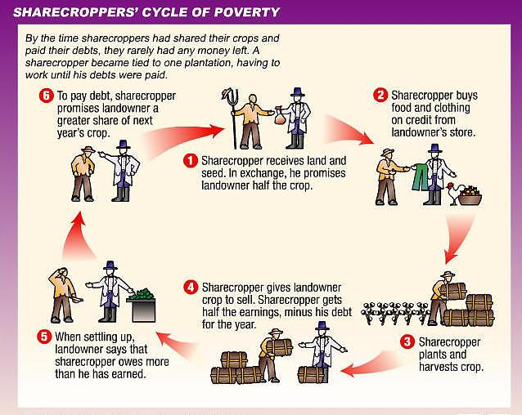
Document Analysis
Based on the document above and your knowledge of U.S. history, what was the real end result of sharecropping?

Document C
Source: Albion Tourgee, Letter on Ku Klux Klan Activities. New York Tribune, May 1870.

Note: Tourgee was a white, Northern soldier who settled in North Carolina after the War. He served as a judge during Reconstruction and wrote this letter to the North Carolina Republican Senator, Joseph Carter Abbott.

It is my mournful duty to inform you that our friend John W. Stephens, State Senator from Caswell, is dead. He was foully murdered by the Ku-Klux in the Grand Jury room of the Court House on Saturday… He was stabbed five or six times, and then hanged on a hook in the Grand Jury room… Another brave, honest Republican citizen has met his fate at the hands of these fiends…
I have very little doubt that I shall be one of the next victims. My steps have been dogged for months, and only a good opportunity has been wanting to secure to me the fate which Stephens has just met… I say to you plainly that any member of Congress who, especially if from the South, does not support, advocate, and urge immediate, active, and thorough measures to put an end to these outrages…is a coward, a traitor, or a fool.

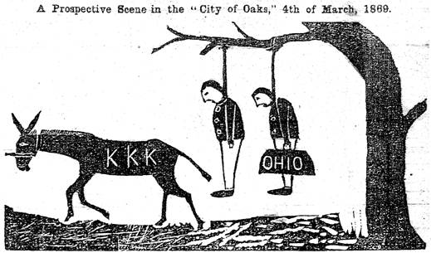
Source: Independent Monitor, September 1, 1868.

Document Analysis
What group(s) is the KKK threatening?

According to Tourgee, what types of people are being attacked by the KKK? Why would the KKK attack these people?

How do these documents help answer the DBQ question?

Document C
Source: Abram Colby, testimony to a joint House and Senate Committee in 1872.

Note: Colby was a former slave who was elected to the Georgia State legislature during Reconstruction.

Colby: On the 29th of October 1869, [the Klansmen] broke my door open, took me out of bed, took me to the woods and whipped me three hours or more and left me for dead. They said to me, "Do you think you will ever vote another damned Radical ticket?" I said, "If there was an election tomorrow, I would vote the Radical ticket." They set in and whipped me a thousand licks more, with sticks and straps that had buckles on the ends of them.

Question: What is the character of those men who were engaged in whipping you?

Colby: Some are first-class men in our town. One is a lawyer, one a doctor, and some are farmers… They said I had voted for Grant and had carried the Negroes against them. About two days before they whipped me they offered me $5,000 to go with them and said they would pay me $2,500 in cash if I would let another man go to the legislature in my place. I told them that I would not do it if they would give me all the county was worth… No man can make a free speech in my county. I do not believe it can be done anywhere in Georgia.
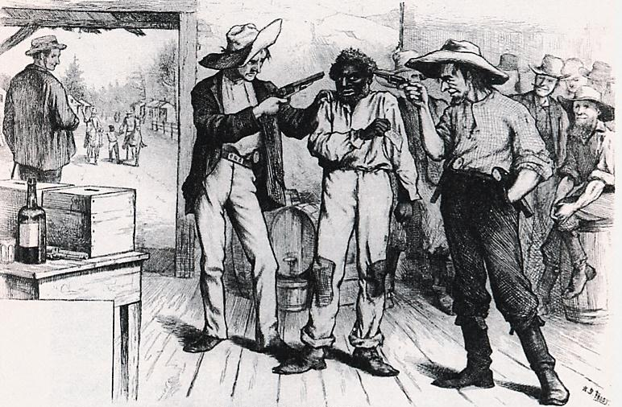

Source: Harper’s Weekly, October 21, 1876.

Caption: “Of Course he wants to vote the Democratic ticket.”

Document Analysis
Why did the KKK attack Abram Colby?

According to Colby, what types of people make up the KKK?

What seems to be the ultimate goal of the KKK?

What is the main idea of the cartoon?
Document D
Source: Gerald Danzer et al., The Americans, McDougall Littell, 1998.

...in the 1870s, Northern voters grew indifferent to events in the South. Weary of the 'Negro Question' and 'sick of carpet-bag' government, many Northern voters shifted their attention to such national concerns as the Panic of 1873 and corruption in Grant's administration....Although political violence continued in the South... the tide of public opinion in the North began to turn against Reconstruction policies.

Source: Kenneth Stampp, The Era of Reconstruction, 1865-1877, Vintage, 1967.

Meanwhile southern Democrats gained strength when Congress finally removed the political disabilities from most of the prewar leadership. In May 1872, because of pressure from the Liberal Republican, Congress passed a general amnesty act which restored the right of office holding [and voting] to the vast majority of those who had been disqualified…After the passage of this act only a few hundred ex-Confederates remained unpardoned.

Document Analysis
Explain the phrases “weary of the ‘Negro Question’” and “‘sick of carpet-bag’ government.”

Why might increased anger about the corruption in government lead to less interest in government attempts to reconstruct the South?

How did the restoration of voting rights to white Southerners undermine efforts to preserve and protect the voting rights of the freedmen?

Document E
Source: Heather Cox Richardson, The Death of Reconstruction: Race, Labor and Politics in the Post-Civil War North, 1865-1901. Harvard University Press, Cambridge, Massachusetts, 2001.

In the fall of 1873, even the staunchly (firmly) pro-Grant and pro-freedman Boston Evening Transcript ran a letter ... arguing that "the blacks, as a people, are unfitted for the proper exercise of political duties.... The rising generation of ... blacks needed a period of probation and instruction; a period ... long enough for the black to have forgotten something of his condition as a slave and learned much of the true method of gaining honorable subsistence and of performing the duties of any position to which he might aspire.

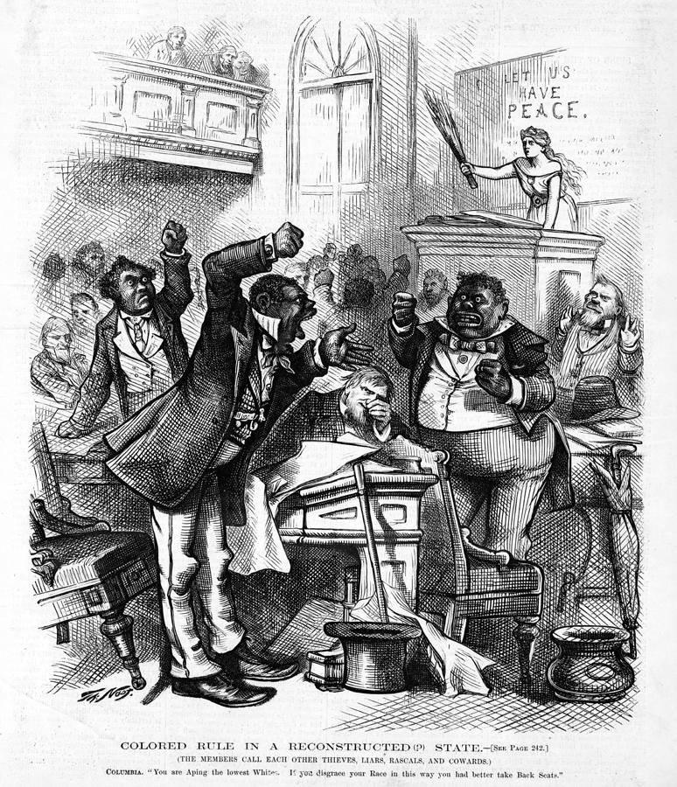

Northern artist’s portrayal of the South Carolina State Legislature during Reconstruction.

Source: The Cover of Harper’s Weekly, March 14, 1874

Document Analysis
According to the letter from the Boston Evening Transcript, why did some people believe blacks were unfit to be government officials? How does this letter show racism existed in the North?

How do this cartoon & letter help explain why Northerners lost interest in Reconstruction?

How does the image above depict black politicians in the South?

Document F
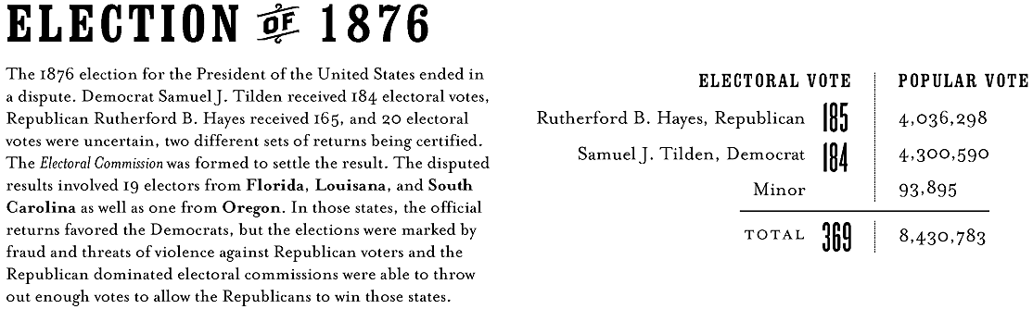
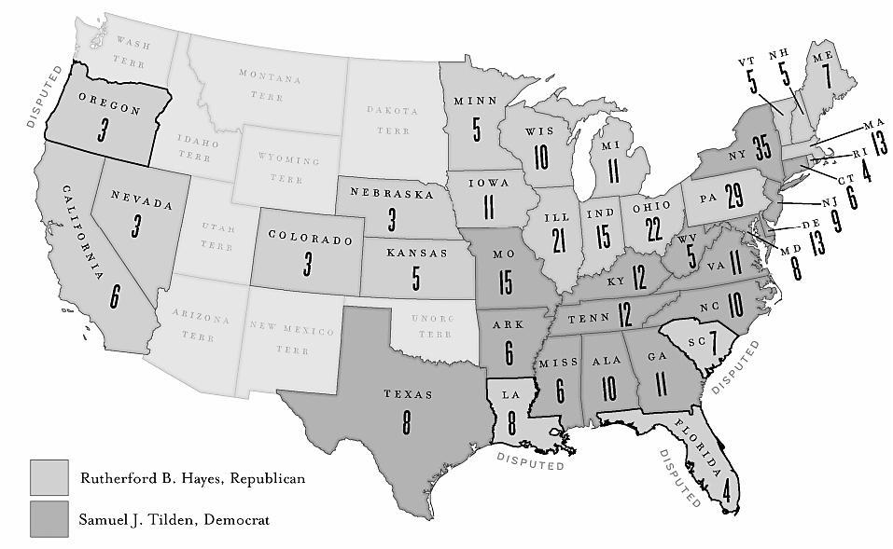
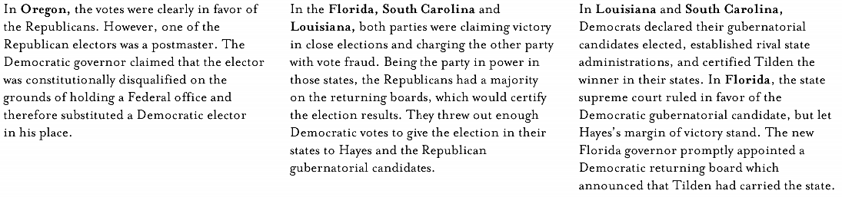
Document Analysis
How was it possible that Hayes “won” the election of 1876?

How did this disputed election lead to the end of Reconstruction?

