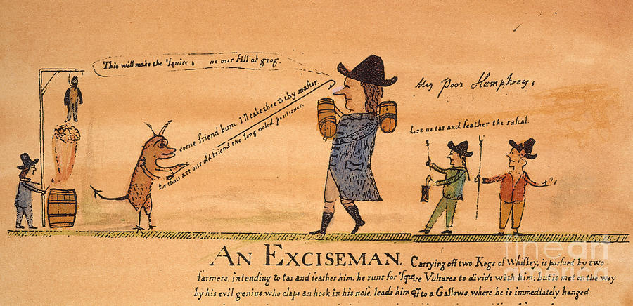
Whiskey Rebellion
1. Which figures in the cartoon are rebels?
2. Which represent that government?
3. Does the cartoonist side with the government or the rebels? How can you tell?

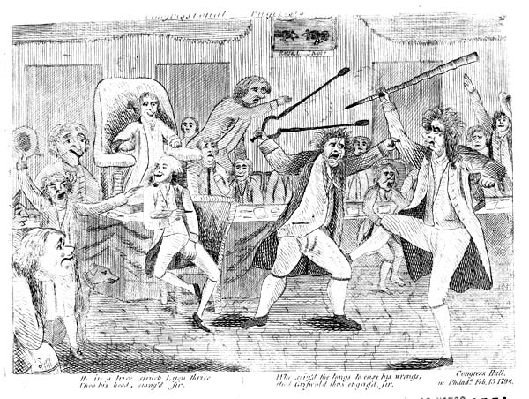
Alien and Sedition Act Cartoon
1. What is the cartoonist view of Congress during the Adam administration? How can you tell?

Political Parties Grow
With the ink barely dry on the Constitution, district political parties were already forming in the United States. The intense debate over ideas that had surrounded the writing of the Constitution shaped the rise of the Federalists and Democratic Republican parties in the new nation.
Federalists | Democratic Republicans
- Led by Alexander Hamilton  - Favored a strong centralized government  - Wanted to base economy on industry and trade  - Were pro-British  - Supported a loose construction of the Constitution | - Led by Thomas Jefferson  - Thought states should have more power  - Wanted to base economy on farming  - Were pro-French  - Supported a strict construction of the Constitution

Thinking Critically
1. Contrast—What were the major differences between the Federalists and the Democratic Republicans?
2. Draw Inferences—Though George Washington supported most Federalist beliefs, he refused to declare himself a Federalist. Why do you think this was so?

Should the US Declare War on Britain?
No American disputed the fact that Britian was interfering with American shipping. Yet while the War Hawks called for war, some people questioned their motives. Read the opinions below, and then decide whether war against Britain was justified.
Grundy Urges War | Randolph Opposes War
“What, Mr. Speaker, are we now called on to decide? It is, whether we will resist by force the attempt, made by [Britain], to subject our maritime rights to the arbitrary and capricious rule of her will…Sir, I prefer war to submission. [This] unjust and lawless invasion of personal liberty, calls loudly for the interposition of this Government…”—Senator Felix Grundy (KY) December 9, 1811 | “Sir, if you go to war it will not be for the protection of, or defense of your maritime rights. Gentlemen from the North have been taken up to some high mountain and shown all the kingdoms of the earth; and Canada seems tempting to their sights…Agrarian [greed], not maritime right, urges the war. [We hear] but one word—Canada! Canada! Canada!” –Senator John Randolph (VA) 16 December 1811

You Decide
1. What is Grundy’s reason for war?
2. Does Randolph believe Grundy? Explain.
3. What decision would you have made?
Cause and Effect
Causes
Cause and Effect
1. Despite ending in stalemate, the War of 1812 had a major impact on the United States. How did it affect American settlers?
- British interfere with American shipping
- British interfere with American expansion into the western frontier
- Southerners want Florida, which is owned by Britain’s ally Spain
- War Hawks want to expel Britain completely from North America
The War of 1812
- Revealed need for a strong standing army
- Encouraged American nationalism
- Brought end to the Federalist Party
- Shattered the strength of Native American resistance
- Paved the way for American acquisition of Florida

