Native American Tribes

Station 1

Using the map on p. 11, please label each of the tribes listed below:
Inuit (located in Canada)
Kwakiutl
Nez Perce
Hopi
Pawnee
Seminole

Next, color the map as noted on page 11, but ONLY to cover the areas these tribes are located in.

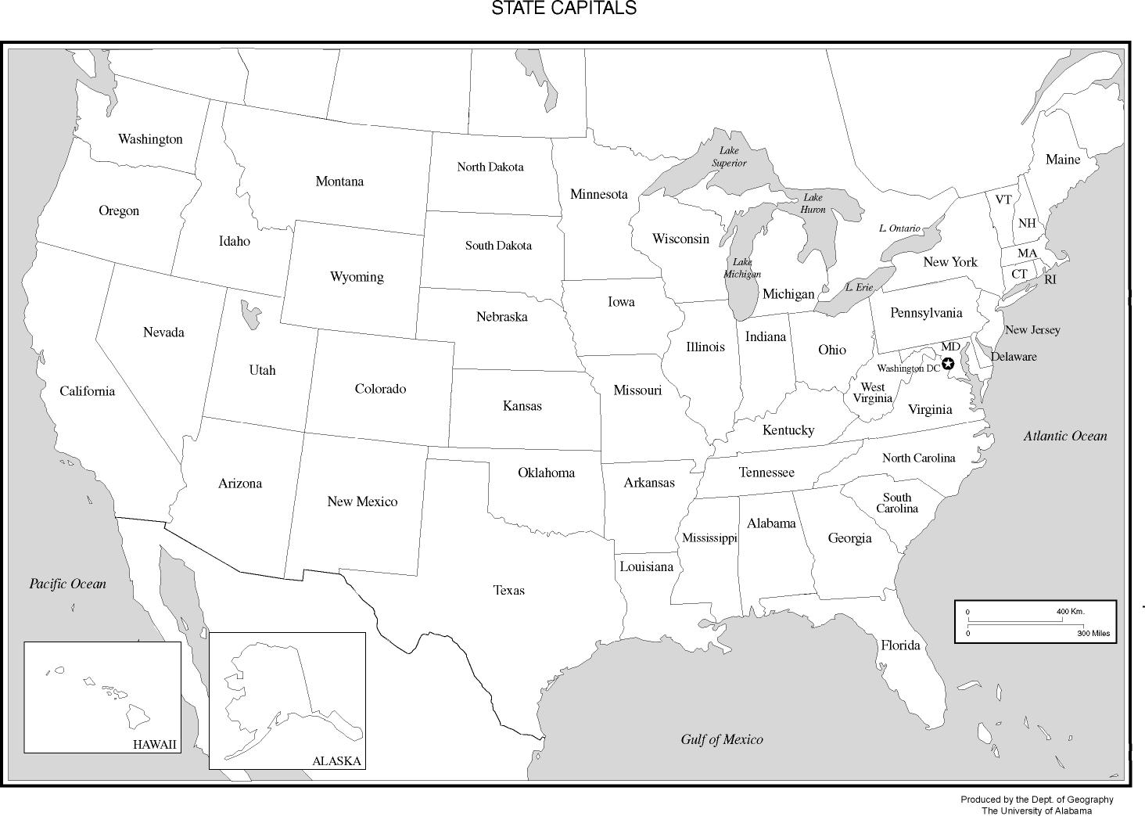

TRIBE | LOCATION | SHELTER | WHAT TO EAT | FAMILY LIFE/ GENDER ROLES | ANSWERS TO (any 4) QUESTIONS
Inuit  (station 2) |  |  |  |  | 1  2  3  4
Kwakiutl  (station 3) |  |  |  |  | 1  2  3  4
Nez Perce  (station 4) |  |  |  |  | 1  2  3  4

TRIBE | LOCATION | SHELTER | WHAT TO EAT | FAMILY LIFE/ GENDER ROLES | ANSWERS TO (any 4) QUESTIONS
Hopi  (station 5) |  |  |  |  | 1  2  3  4
Pawnee  (station 6) |  |  |  |  | 1  2  3  4
Seminole  (station 7) |  |  |  |  | 1  2  3  4
On your own:

Fall is almost here and November is coming up soon! Besides cooler weather and football, the fall brings with it Native American Heritage month, which is recognized in November.

For too long, people have believed all Native American tribes are the same and that they are all just like Pocahontas.

Directions: You have just been hired as the new graphic designer for the mega-million dollar t-shirt company, EduShirts. Your first project as graphic designer is to create a t-shirt to help other people understand the truth about different Native American tribes. Remember- create a t-shirt that is not only attractive and will sell, but provides people with quality educational information.

For your t-shirt, make sure that represents one of the Native American tribes we have learned about. It must include: visual representation of ONE (1) Native American Tribe, the name of the tribe and you are to create a slogan that best represents that tribe. Make sure your creation is neat and colored. You want to get that bonus as a graphic designer for your t-shirt being the selection as the Native American Heritage Month official shirt!
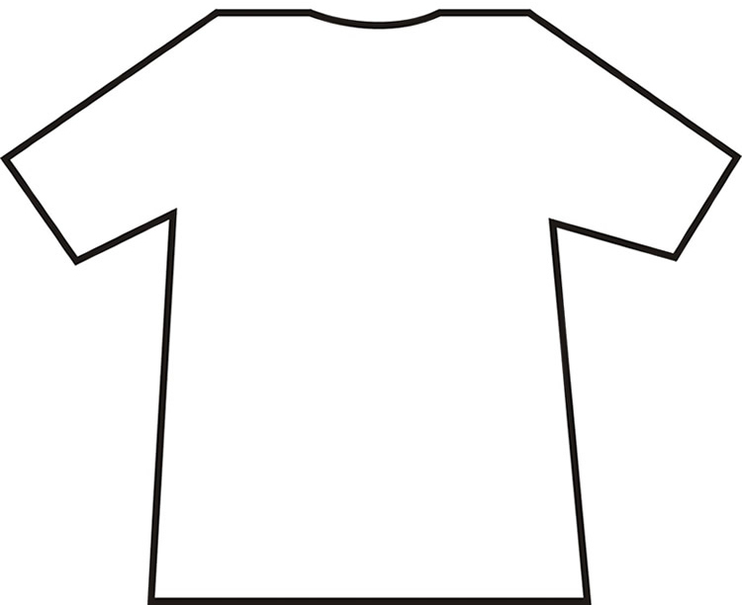
Rubric: (out of 6 points)
______/ 2 : Accurate information for the tribe represented visually
_____/1: neat and colored
______/1: Name of the tribe on the shirt Total points:
______/1: Slogan for the tribe Grade:
FRONT
BACK

