Unit 1: Columbian Exchange & Colonies
- Map – fill out the items that came to and from the United States through the Colombian Exchange.
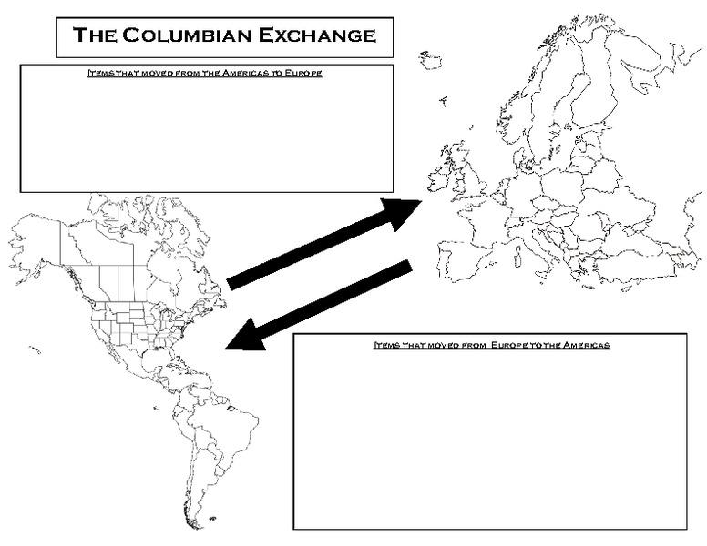

Voyages of Discovery: Unit 1
2.What were the main reasons for the Voyages of Discovery? | 3.What technology helped make the voyages go further? | 4.What were the effects of the voyages of discovery on Native Americans?
Colonial Foundations – What area some key characteristics of how each area colonized? Unit 1
5.Northern / New England Colonies | 6.Middle Colonies | 7.Southern Colonies
8. The difference in the economic development of the New England, Middle, and Southern colonies resulted primarily from which of the following?
a. geographic diversity
b. customs of the immigrants
c. methods of governing the colonies
d. the extent of education in the colonies

9. Which statement most specifically sums up why the early colonists came to North America?
a. The colonists were fleeing hard times in Europe.
b. The colonists came for work and religious freedom.
c. The colonists came for adventure.
d. The colonists came to start a new life.
10. Samuel Adams and others called the confrontation between British soldiers and civilians in March of 1770 the “Boston Massacre” in order to
a. Sway public opinion against the British
b. Describe the event as truthfully as possible
c. Inspire foreign countries to support the colonies
d. Encourage Parliament to repeal the Intolerable Acts

11. Which conflict created the debt that American colonists were expected to repay to Great Britain during the 1760’s?
a. French and Indian War
b. Spanish-American War
c. Glorious Revolution
d. American Revolution

Unit 2 – American Revolution:
12. Table: What occurred on each date? (HINT: Use your American Revolution Packet-also located on our class website)

1754

1763

1765

1765

1767

1770

1773

1774

1776

13. Mercantilism is the idea that nations could become powerful through wealth. How did this economic ideology affect England’s relationship with her North American colonies? |  |  | 14.What affect does salutary neglect have on Colonial America?
15.In the event known as the Boston Massacre, five men died. Why is this event a “big deal?” How did it lead to the revolution? | 16.In 1773, the colonists staged a protest against the Tea Act known as the Boston Tea Party. How does England retaliate?  17.What do the colonists call these actions? |  |  | 18. Why is Thomas Paine’s pamphlet considered an important revolutionary event?
19.Even though the revolution was about many things, one of the common themes is summarized in the quote “No Taxation Without Representation.” Based on this quote, what were the colonists really protesting? |  | 20.One year prior to the Declaration of Independence, the Olive Branch Petition was signed and given to the King. How is this document different from the Declaration of Independence in its intentions?

Unit 3: Constitution
21. The following list of terms in some way contributed to the shaping of US Constitution. For each term, describe in the box how each event / document contributed.

Magna Carta Enlightenment Mayflower Compact

Va. House of Burgesses John Peter Zengar Case Maryland Toleration Act

Declaration of Independence American Revolution Articles of Confederation

US Constitution

Unit 3: America experiences its first political battles:
22. State Decision-Making
Virginia Plan
New Jersey Plan

1. 1.

The Connecticut Compromise

___________ legislature (Two-House)
____________ _________________
2 per state based on population

23. Representation and Slaves
North:
South:
Compromise:

24. Two groups form…

Federalists | Anti-Federalists

25. What compromise do the 2 groups above come to? ___________________________
- Bill of Rights-Directions: Write the number of the amendment on the line (1-10)
a. __________Trial by jury in civil cases over $20
b. __________Powers not named go to the people
c. __________No quartering of soldiers
d. __________Right to bear arms
e. __________Right to a speedy trial & the right to an attorney
f. __________No unreasonable search and seizure
g. __________Freedom of speech, religion, press and petition
h. __________Rights of the accused: Right against self-incrimination, no double jeopardy, “due process” of law
i. __________Powers not named go to the people and the states
j. __________No cruel and unusual punishment& no excessive bail
Principles of the US Constitution:
Principle | Explanation (what does this mean?)
27.Popular Sovereignty
28.Limited Government
29.Checks and Balances
30.Separation of Powers
31.Federalism
32.Judicial Review

Which principle is it? (popular sovereignty, limited government, checks & balances, separation of powers, federalism, judicial review)
- If the Congress passes a bill the president can veto the bill, then the Congress can override his veto with a 2/3 vote.______________________________________

- The US Supreme Court can declare acts of the President or the Congress unconstitutional.___________________________________

- The Constitution divides the federal government into three branches (legislative, executive & judicial). __________________________

- The power of the US government is derived (comes) from the people. _______________________

- The power of the government is regulated by the people and the US Constitution ___________________

- In the United States we have a strong national government which shares some power with lower state governments._______________________________

- Which principles of the Constitution prevent all the power of the government from being in the hands of one person or one branch of government?_______________________________

TYPES OF POWERS: concurrent, delegated, reserved.
- The power of the states and federal government to collect taxes and build roads are an example of __________________ powers.

- The power of the US Congress to declare war is an example of a ____________________ power.

- The power of the states to establish schools is an example of a ___________________________ power.

