Marbury v. Madison DBQ

Exercise A. Analyzing Sources

Directions: Answer the questions that follow each document.

Document 1:

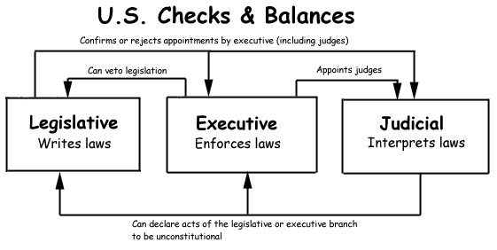

1. Which branch of government has the power to declare acts (laws) of Congress unconstitutional?

______________________________________________________________________

Document 2: Excerpts of Supreme Court Chief Justice John Marshall’s 1803 decision in Marbury v. Madison.

It is emphatically the province and duty of the judicial department to say what the law is. Those who apply the rule to particular cases must, of necessity, expound and interpret that rule. If two laws conflict with each other, the courts must decide on the operation of each.
So if a law be in opposition to the Constitution; if both the law and the constitution apply to a particular case, so that the court must either decide that case conformably to the law, disregarding the Constitution; or conformably to the Constitution, disregarding the law; the court must determine which of these conflicting rules governs the case. This is of the very essence of judicial duty.
If, then, the courts are to regard the Constitution, and the Constitution is superior to any ordinary act of the legislature, the Constitution, and not such ordinary act, must govern the case to which they both apply…

From these, and many other selections which might be made, it is apparent that the framers of the Constitution contemplated that instrument as a rule for the government of courts, as well as of the legislature.
Why otherwise does [the Constitution] direct the judges to take an oath to support it? …
It is also not entirely unworthy of observation that, in declaring what shall be the supreme law of the land, the Constitution itself is first mentioned; and not the laws of the United States generally, but those only which shall he made in pursuance of the Constitution, have that rank.
Thus, the particular phraseology of the Constitution of the United States confirms and strengthens the principle, supposed to be essential to all written constitutions, that a law repugnant to the Constitution is void; and that courts, as well as other departments, are bound by that instrument.
The rule must be
Discharged.

http://www.constitution.org

2A. The 1803 Supreme Court case of Marbury v. Madison established the Supreme Court’s power of judicial review (the power to declare acts of Congress unconstitutional). What did Marshall mean by the phrase “It is emphatically the province and duty of the judicial department to say what the law is”? (tip – write in kid language)

2B. What does Marshall say is the duty of the court “when a law is repugnant to the Constitution”?

2C. What is important about the court “voiding” a law?

Document 3:

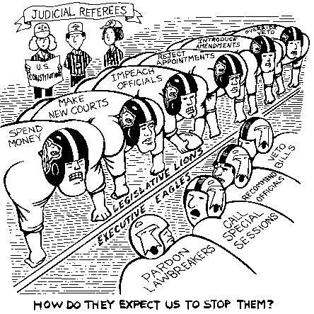

3A. What three groups in government are represented in this cartoon?

3B. What is represented by the writing on the backs of the players?

_____________________________________________________________________
3C. What are the referees using as their “rulebook”?

_____________________________________________________________________
3D. What power did Marbury vs. Madison give the “referees” that is not shown in the cartoon?

3F. How does judicial review strengthen the role of the judicial branch in this game?

_____________________________________________________________________________ _____________________________________________________________________________

Exercise B. Writing About Related Sources

Directions: Write a paragraph in response to The Big Question below. Be sure to include in your answer at least two details from the documents on the previous pages. Reviewing your responses to the scaffolding questions will help you answer The Big Question well.

The Big Question:

Does judicial review really strengthen the Constitutional principal of checks and balances or not? Justify your answer.

_____________________________________________________________________________

_____________________________________________________________________________

_____________________________________________________________________________

_____________________________________________________________________________

_____________________________________________________________________________

_____________________________________________________________________________

_____________________________________________________________________________

_____________________________________________________________________________

_____________________________________________________________________________

_____________________________________________________________________________

_____________________________________________________________________________

_____________________________________________________________________________

_____________________________________________________________________________

_____________________________________________________________________________

(See Rubric next page)

DOCUMENT-BASED QUESTION GENERIC SCORING RUBRIC

4 | 3 | 2 | 1
Answers all the questions by referring to the documents and bringing in new information |  Answers most of the questions and refers to the documents |  Answers some of the questions and refers to some of the documents |  Answers none of the questions and does not use the documents to support ideas.
 Consistently uses accurate data |  Generally uses accurate data |  Uses some accurate data |  Uses no accurate data
 Fully develops ideas by using examples, reasons, details, and explanations that support the topic |  Somewhat develops ideas with supporting evidence |  Uses little supporting evidence to develop ideas |  Uses no supporting evidence
 Demonstrates a  logical plan of organization |  Uses some organization |  Attempts to organize but goes off topic |  Lacks  organization of ideas
 Consistently expresses ideas clearly |  Usually expresses ideas clearly |  Attempts to  express ideas clearly |  Does not express ideas clearly
Comments: | Comments: | Comments: | Comments:

