Manifest Destiny Primary Source Analysis
Witness to History
1800-1850
A Pioneer Woman Heads West  On April9, 1853 Amelia Stewart Knight left Iowa with her family to join a wagon train headed for Oregon. Her diary describes many of the hazards of the five month trek, from extreme heat or cold to poisonous water. It also reports encounters—some cordial and some tense—with Native Americans. In one entry, Knight wrote: | “After looking in vain for water, we were about to give up as it was near night, when husband came across a company of friendly Cayuse Indians about to camp, who showed him where to find water, half mile down a steep mountain, and we have all camped together, with plenty of pine timber all around us…We bought a few potatoes from an Indian, which will be a treat for our supper.”—Diary of Mrs. Amelia Stewart Knight, 1853 | A. For what were the Knights looking?  B. How did the Indians help them?
A Child at the Alamo  In march 1836, Mexican troops attacked the Alamo in San Antonio, Texas. Among those inside the old mission was eight year old Enrique Esparza. His father, Gregorio, was one of a group of Texans engaged in a struggle to win independence from Mexico. Some 70 years later, Esparza recalled hearing sounds of shooting at two in the morning: | “I heard my mother say: ‘Gregorio, the solders have jumped the wall. The fight’s begun.’ He got up and picked up his arms and went into the fight. I never saw him again….It was so dark that we couldn’t see anything, and the families that were in the quarters just huddled up in the corners. My mother’s children were near her. Finally they began shooting through the dark into the room where we were . A boy who was wrapped in a blanket in one corner was hit and killed”—Enrique Esparza, San Antonio Express, 1907 | A. What do you think it would be like to be in the middle of a battle like the one described?
Seeking a Mountain of Gold  By 1849, poor farmers in China had received word of a “mountain of gold” across the Pacific Ocean. Soon, thousands of Chinese men joined fortune seekers from all over the world in a rush to the gold fields of California. However, the Chinese newcomers often faced hostile reception. In a letter home to his parents, one young American miner described the unfair treatment of Chinese miners: | “They are coming by thousands all the time. The miners hear drove off about 200 Chinamen about two weeks ago but they have come back about as thick as ever (I would not help drive them off as I thought they had no right to drive them).”—Robert W. Pitkin, 1852 | A. According to Pitkim, how did the American miners treat the Chinese newcomers?  B. What is Pitkin’s attitude toward his fellow miners?

Analyzing Visuals
The Lure of California Gold  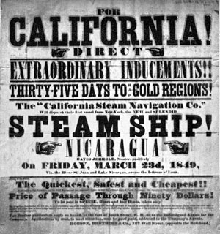  1. What does the advertisement suggest about the Gold Rush? | Mountain Men  1. What dangers do you think mountain men faced?  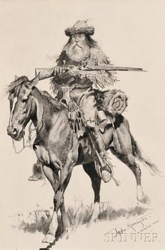  2. Why do you think they were willing to face them?
Focus on Geography
Trails to the West
During the 1840s alone nearly 20,000 Americans migrated to California, Oregon, and Utah along the major overland trails. The trails also became trade routes, carrying merchants and goods in both directions.
Oregon Trail  Most emigrants on the Oregon Trail were farmers, and their final destination was the fertile land of the Willamette Valley. They packed their family and everything they could carry—from cast-iron stoves to the family Bible—onto covered wagons | Mormon Trail  The final destination for Mormon emigrants was the Great Salt Lake in present day Utah. Through extensive irrigation and farming, Mormon settlers permanently altered their desert environment.
Westward Migration, 1840s
Western Trail | Number of Settlers | Where to | When
California Trail | 2700 | California | 1842-1848
Mormon Trail | 4600 | Utah | 1847-1848
Oregon Trail | 11500 | Oregon | 1842-1848

Supplies for Travelers  Forts along the overland trails provided more than protection. They were also homes to trading posts, where wagon trains could replenish their supplies. | Donner Pass  For emigrants, mountain passes could be a getaway to their final destination—or a snowy tomb. The Donner Pass was named for a party who got trapped in the Sierra Nevada’s in the winter of 1846-1847. Nearly half died of starvation, and the survivors resorted to eating their dead.
Geography and history
1. How did the goals of the travelers on the Oregon and Mormon trails differ? How were they similar?
2. Do deserts and mountain passes still present a hazard to travelers today? Why or why not?

Analyzing Points of View
Should the United States Annex Texas?
From the time it achieved independence, Texas sought US statehood. America’s leaders had to decide whether to annex Texas. The 1844 presidential rivals James Polk and Henry Clay disagreed on the issue. Read their views below. Then, you make the call.
Polk Favors Annexation  “None can fail to see the danger to our safety and future peace if Texas remains an independent state or becomes an ally or dependency of some foreign nation more powerful than herself. Is there one among our citizens who would not prefer perpetual peace which with Texas to occasional wars, which so often occur between bordering independent nations”—James K. Polk, inaugural address, 1845 | Clay Opposes Annexation  “Annexation and war with Mexico are identical. Now, for one, I certainly am not willing to involve this country in a foreign war for the object of acquiring Texas…I regard all wars as great calamities, to be avoided, if possible, and honorable peace as the wisest and truest policy of this country.”—Henry Clay, “Raleigh Letter,” 1844
You Decide
1. Why did Polk think annexation would promote peace?
2. Why did Clay think annexation would lead to war?
3. What decision would you have made? Why?

San Francisco: Growth of a City
A Fast Trip West  This 1851 advertisement promises a superfast trip from New York around the southern tip of South America to San Francisco—in as little as 97 days! | Street Scene  This painting shows a busy street market in 1850 San Francisco  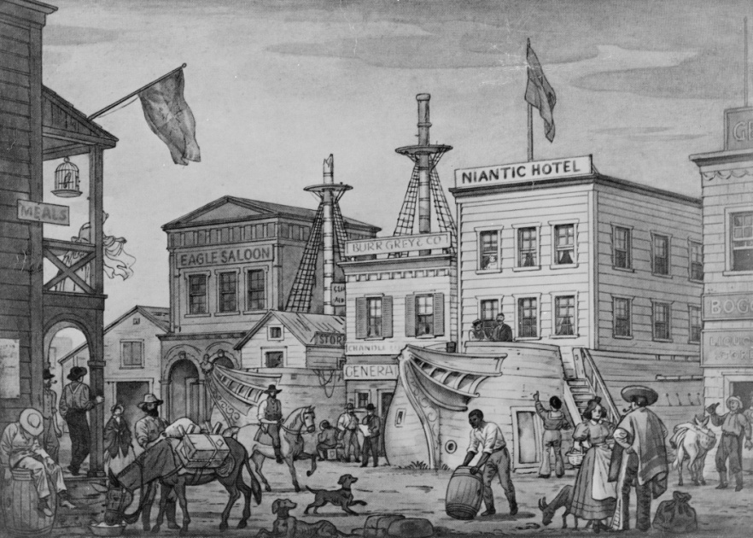
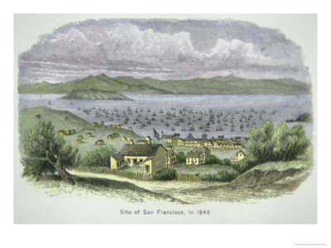  San Francisco 1848 | San Francisco 1850  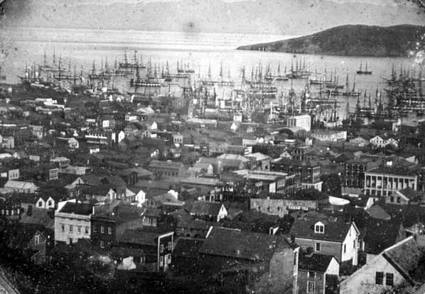
Growth of San Francisco
Year | Population
1848 | 800
1849 | 25,000
1852 | 36,000
1860 | 57,000

Thinking Critically
1. Draw Inferences—What kind of businesses do you think sprang up in San Francisco as a result of the Gold Rush?
2. Draw Conclusions—What other circumstances might cause rapid changes in a city’s population?
For those travelling by ship, San Francisco was the gateway to the California gold fields. It was also a place where miners could come to buy supplies, exchange gold for cash, or relax. Through migration and trade San Francisco quickly became the major American city on the Pacific coast in the 1800s.

