Life in Colonial America Notes: PART 1
Directions: Using the website listed on the class weebly (www.edwardsamerican1.weebly.com), please read and gather the information for the following categories.
 | New England Colonies | Middle Colonies | Southern Colonies
RELGION
GOVERNMENT
TRADE and ECONOMY
GEOGRAPHY
NATRUAL RESOURCES
CLIMATE

Key Terms/People (use the website links or another website to define the following):
- Royal Colony

- Proprietary Colony

- Anne Hutchinson:

- Roger Williams

- Jamestown

- Bacon’s Rebellion

Life in Colonial America Notes: PART 2
Directions: As you transition to the correct station, please read over the information and answer the questions that follow.

Leisure
- How were work and fun combined in the colonies?

- How do you see work and fun combined in today’s world?

- Name the toys used by the children:

Name the games played by the children:

Name the sports played:

Education
- Which economic class most likely had teachers/tutors for their children?

- How did different religious views slow down educational growth in the Middle colonies?

- How were New England towns different in regards to education?

- Draw a picture of what school looked like in the colonies:

African Americans
- Which colonies had slaves?

- Fill in what was traded through Triangular trade for each area
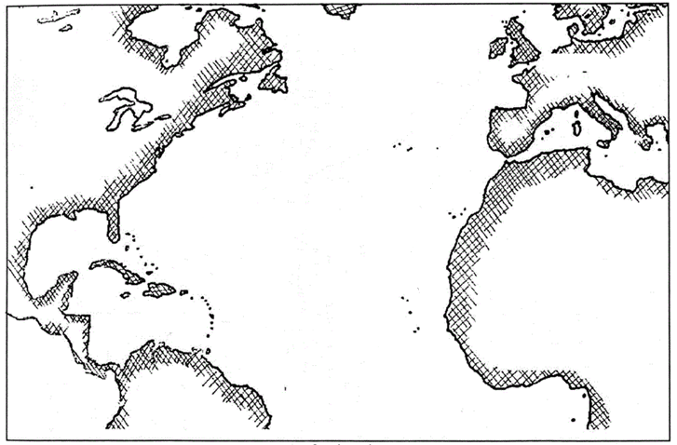

- What types of jobs did slaves have?
Crime and Punishment
Please fill in the chart:
Types of Crimes | Examples | Punishment
- Very Serious
- Moderately Serious
- Lesser Crimes

Life on a Farm
- Name the hardships/dangers of farm life:

- Draw a picture that best represents farm life in the colonies:

