Coastal Plain

[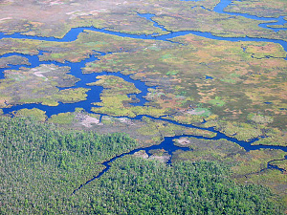](http://www.google.com/url?sa=i&rct=j&q=&esrc=s&source=images&cd=&cad=rja&uact=8&docid=pMtYwf-TIyUhvM&tbnid=e07RN6qoZ-hmOM:&ved=0CAUQjRw&url=http://www.dcr.virginia.gov/natural_heritage/natural_communities/ncoverview.shtml&ei=Zd5qU42kB-Kc0AXF5oCwAw&bvm=bv.66330100,d.aWc&psig=AFQjCNFDs5L2woMSReOTSHgDIGQlJoXDZw&ust=1399599009570194)[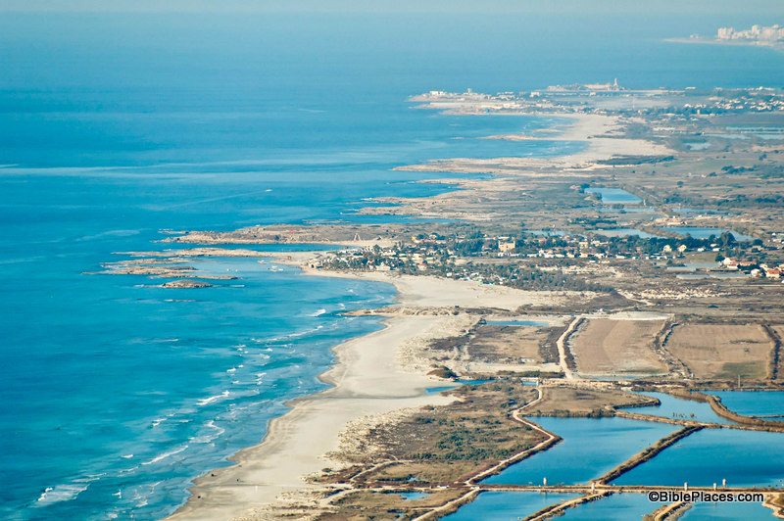](http://www.google.com/url?sa=i&rct=j&q=&esrc=s&source=images&cd=&cad=rja&uact=8&docid=pMtYwf-TIyUhvM&tbnid=e07RN6qoZ-hmOM:&ved=0CAUQjRw&url=http://wild-olive-shoot.blogspot.com/2012/12/biblical-geography-coastal-plain-plain.html&ei=Pt5qU4KbB6-v7AbY9YHAAQ&bvm=bv.66330100,d.aWc&psig=AFQjCNFDs5L2woMSReOTSHgDIGQlJoXDZw&ust=1399599009570194)

Coastal plains are located along major bodies of water such as oceans and gulfs. These lowland areas have many excellent harbors for ships to dock. The interior of this area is made of fertile plains littered with rivers and tributaries. The area is divided from other geographic regions by rugged mountains.

[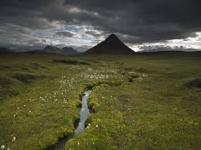](http://www.google.com/imgres?imgurl=http://www.icelandtravel.is/servlet/file/store5085/item350822/version1/fileservice2049/350822_2049_preview.jpg&imgrefurl=http://www.icelandtravel.is/self-drive-tours/detail/item656720/Highlands_and_Glaciers/&h=751&w=1000&tbnid=kvjnzPzqXU7VkM:&zoom=1&docid=yQUjk7MUmH7A_M&ei=TeFqU9f9IMSCyAGC7oCQCw&tbm=isch&ved=0CJgBEDMoJjAm&iact=rc&uact=3&dur=3573&page=2&start=20&ndsp=27)[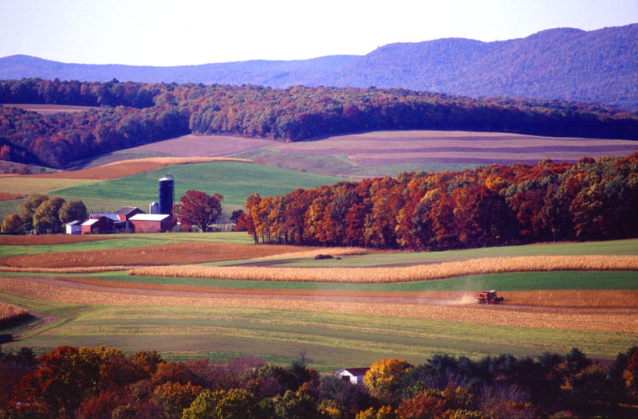](http://www.google.com/url?sa=i&rct=j&q=&esrc=s&source=images&cd=&cad=rja&uact=8&docid=AgXoWTpQkPBB_M&tbnid=mHSZJ7pT2_9h_M:&ved=0CAUQjRw&url=http://walkergood.wikispaces.com/Interior+Lowlands&ei=c-FqU83ILsrs0gWGzIHQCw&bvm=bv.66330100,d.aWc&psig=AFQjCNHflWHSr-AauUV-nL8XpBFUk9wRXQ&ust=1399599822118925)Interior Lowlands

Interior lowlands are made up of rolling hills that contain large grassy areas, rivers, and broad river valleys.

[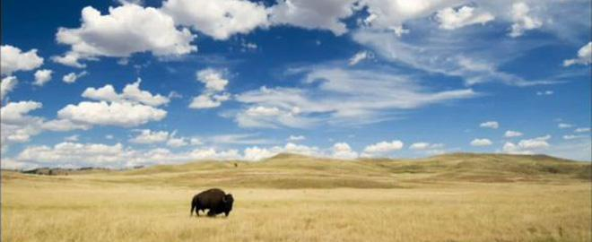](http://www.google.com/url?sa=i&rct=j&q=&esrc=s&source=images&cd=&cad=rja&uact=8&docid=Kt6o2BSWhgkRmM&tbnid=s6ykYlTy2hiYJM:&ved=0CAUQjRw&url=http://netnebraska.org/basic-page/television/great-plains-americas-lingering-wild&ei=e-RqU4jHKOKc0AXF5oCwAw&bvm=bv.66330100,d.aWc&psig=AFQjCNEDzHqVDoLbIG5kYz0AOQeSOOGHqw&ust=1399600625338070)[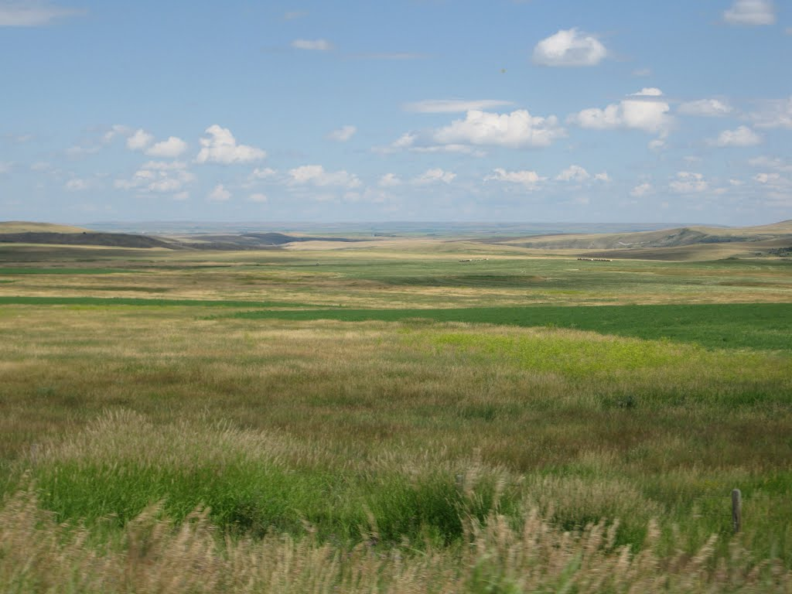](http://www.google.com/url?sa=i&rct=j&q=&esrc=s&source=images&cd=&cad=rja&uact=8&docid=HfP8_ad6p3rgDM&tbnid=v1GhJxBesoG9qM:&ved=0CAUQjRw&url=http://www.panoramio.com/photo/66665687&ei=sORqU6O4J6Oy0QWU9oGwCg&bvm=bv.66330100,d.aWc&psig=AFQjCNEDzHqVDoLbIG5kYz0AOQeSOOGHqw&ust=1399600625338070)Great Plains

The Great Plains are located in interior areas (landlocked). They are large, flat areas that are known for their miles of rich grasslands.

Mountains

[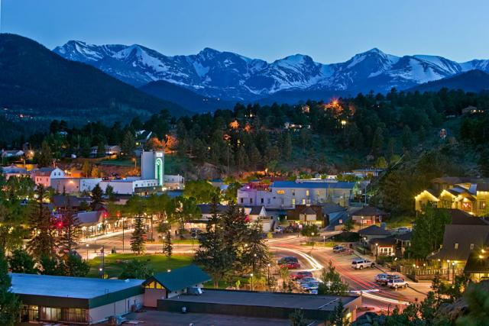](http://www.google.com/url?sa=i&rct=j&q=&esrc=s&source=images&cd=&cad=rja&uact=8&docid=O0OHcHoPzDwLAM&tbnid=5KuSJ-SwAJmTpM:&ved=0CAUQjRw&url=http://alphaholidaylettings.blogspot.com/2012/12/rocky-mountains-colorado.html&ei=F-ZqU4D_Lc-z0QXatYDYBA&bvm=bv.66330100,d.aWc&psig=AFQjCNEAOaCCw0x38teWYEiQlYAK1eSp-A&ust=1399600993467503)

Mountainous areas are very rugged but have valleys with which to build on. Despite the high elevation, summers can be pleasant although winters are very cold. Rivers and lakes dot the landscape.

Desert

[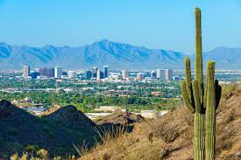](http://www.google.com/imgres?imgurl=http://www.name-badges.com/images/name-badges/phoenix-arizona-name-badges.jpg&imgrefurl=http://www.name-badges.com/phoenix-arizona-name-badges.php&h=479&w=720&tbnid=VYd2q0o0FQp9EM:&zoom=1&docid=yknygd4tI3bEkM&ei=4-dqU7vmJci4yAGhsoGAAg&tbm=isch&ved=0CIkBEDMoGjAa&iact=rc&uact=3&dur=2458&page=2&start=18&ndsp=24)[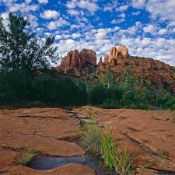](http://www.google.com/url?sa=i&source=images&cd=&cad=rja&uact=8&docid=PtV8GY4m9EY5rM&tbnid=OGVKwy7dkNbNrM&ved=0CAgQjRw&url=http://www.us89society.org/LinkClick.aspx?link=170&tabid=163&ei=fedqU-vsC6zyyAGNi4GwBg&psig=AFQjCNGTI_VpgwWzMSbvB7_M94dgRK8LDg&ust=1399601405385622)

Desert regions see very little rainfall but can have access to major rivers that flow down from local mountain ranges. Elevations are typically flat but there can be areas of rolling hills.

[](https://www.google.com/imgres?imgurl=http://paradiseintheworld.com/wp-content/uploads/2012/03/honolulu-hawaii.jpg&imgrefurl=http://paradiseintheworld.com/honolulu/&docid=VHS3MoeQ2gG_1M&tbnid=mfGktyRgiW-RSM&w=1280&h=960&ei=q-lqU46RLeab1AXb-YHgDg&ved=0CAMQxiAwAQ&iact=c)[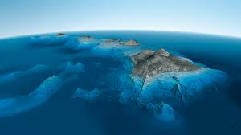](http://www.google.com/imgres?imgurl=http://p1.pichost.me/i/52/1755067.jpg&imgrefurl=http://pichost.me/1755067/&h=1080&w=1920&tbnid=GoIwmbZOLmqzPM:&zoom=1&docid=vt_tQ8LIjEEcFM&ei=YOlqU_SpLejhygHJ6YC4Cg&tbm=isch&ved=0CBsQMygTMBM4ZA&iact=rc&uact=3&dur=1744&page=5&start=98&ndsp=24)Island

Islands are surrounded and there can be multiple islands of varying size in a chain. Islands also contain varying landscapes, anywhere from high level mountains to lowland valleys. They also contain miles of beaches.