**French and Indian War (1754-1763)**

**Rising Tensions…**

By 1700,

Expansion of French into Ohio Valley alarmed English.

Both sides ___________________________

____________________________________

**Lead-Up**

No one knows for sure who has claims to the Ohio River Valley.

After Virginia ______________________________, the

French retaliate by ____________________________

_____________________________________________

Washington tries to capture Fort Duquesne and fails. This leads to:

*France*: loses ________________, gains land __________

_______________________________________________

*Spain*: gains _____________________________________

_______________________________________________

*England*: gains ____________________________________

______________________, rights to salve trade

Treaty of Paris ( )

Ends the war.

Marks:

Continent now controlled by:

Boundary:

**Albany Plan**

________________________ thinks the colonies need to ________________________________

Each colony would keep its own government, but there would be ____________________________

Colonists:

**Two Front War**

___________________ is part of a larger war, called the 7 Years War

Initially, the ____________ were winning because:

1.

2.

Eventually, the ____________ commit more troops to the war and turn the tide.



Effects of War on Colonies:

1.

2.

3.





Effects of War on England:

1.

2.

3.



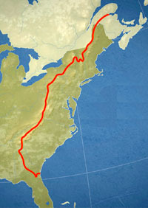

This is the:

Created by King George in order to:

Colonists felt:

Why?