FOUNDING DOCUMENTS!

MAGNA CARTA 1215

- What was the Magna Carta?

2. Why was it so important?

3. Discuss: What is an example of how it influences our government today?

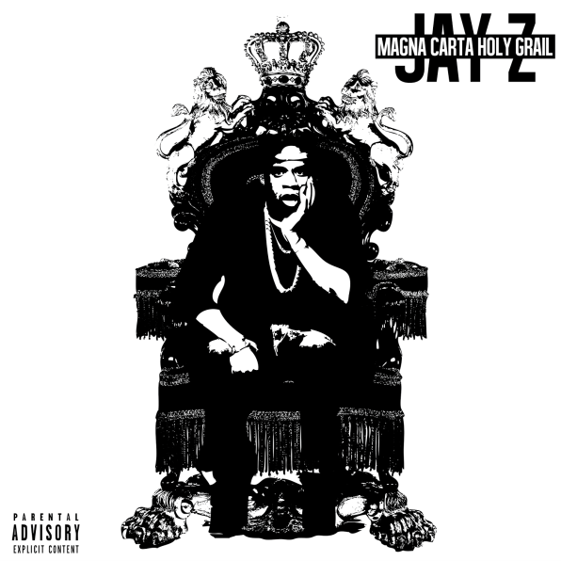

The Virginia House of Burgesses (1619)

1.What was the Virginia House of Burgesses?

2.What is a representative government?

3.What is a bicameral legislature?

4.Where do we see the impact of the Virginia House of Burgesses on our government structure today?

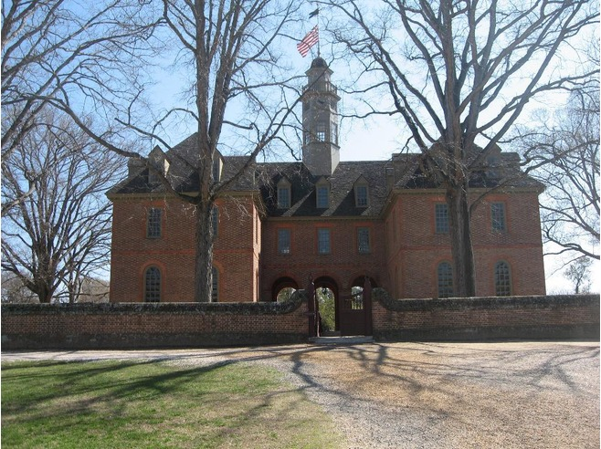
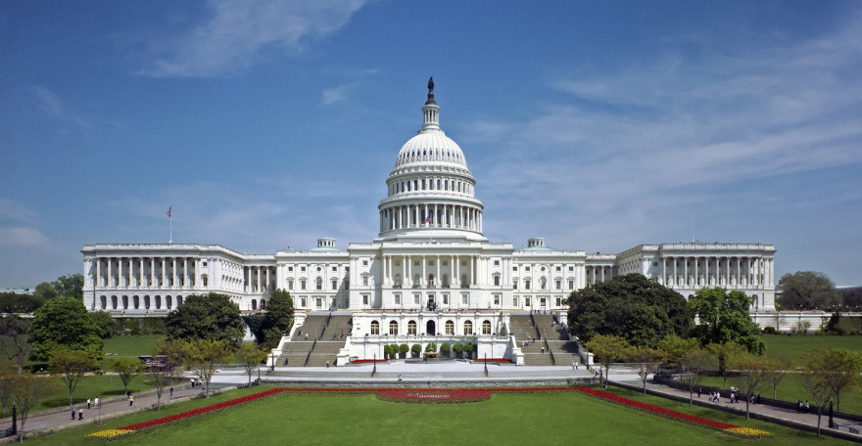 U.S. Congress

Mayflower Compact (1620)

1.What was the Mayflower Compact?

2.What is a social contract?

3.What is self-government?
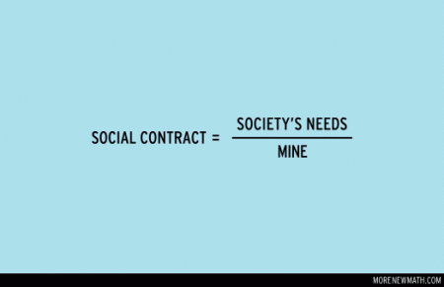

Fundamental Orders of Connecticut (1639)

- What is the Fundamental Orders of Connecticut?

- Why was the Fundamental Orders of Connecticut important?

- How did this document influence our government today?

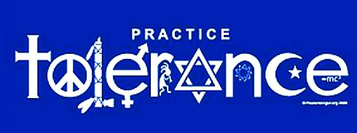
Maryland Toleration Act (1649)

- What was the Maryland Toleration Act?

- What does religious tolerance mean?

- How did this act inspire parts of our government today?

Zenger Case (1734)

1.What did Peter Zenger do that got him put in jail?

2.How does the outcome of the Zenger case impact parts of our government today?

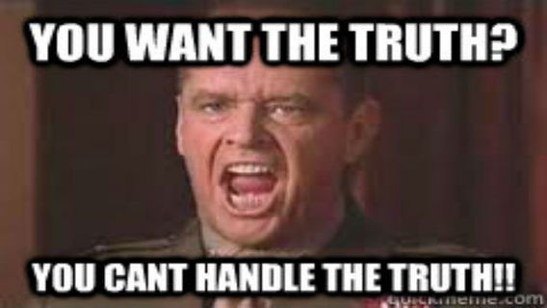
3.Under what type of government would Zenger have most likely not been released from jail? Why?

