**The Fugitive Slave Act**

The provisions of the Act included: fugitives were not permitted a ________________ by jury, fugitives could not ________________ on their own behalf, just a statement from the ___________________ was needed for a slave to be returned , $10 was offered when fugitives were _________________, and those found helping a fugitive had to pay $__________ fine and serve six months in ____________________.

**Slavery in New Territories**

The _____________________ was an amendment introduced by Pennsylvanian Democrat David Wilmot stating that slavery would not exist in any territory the US might acquire as a result of war with ____________________. The House approved the amendment but the Senate _____________ it.

California entered the Union as a _____________ state, which caused alarm for the ___________. President Zachary ________________ supported the admission of California and said the South could counter ___________________ more effectively if they left slavery up to each _________________ and not __________________.

What area of the country would approve of the Fugitive Slave Act? What area would not approve? Why?

Who did President Taylor say should decide if a state was free or slave?

What type of state was California?

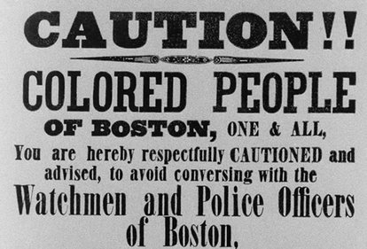

Why would the Underground Railroad need to be a secretive system? What might happen if the slaves were caught?

Who is this poster intended for?

What may happen if they are caught?

**Resistance to the Act**

Some Northerners organized committees to send endangered African Americans to ___________________. Some northern states passed _________________________ laws which forbade the imprisonment of runaway slaves and guaranteed they would have jury trials. The ___________________ Railroad developed. It was run by _______________ African Americans and white ________________________ which hid _______________ slaves in secret tunnels and false cupboards providing them food and clothing and passage to the next station. Harriet ___________________, known as Moses, helped 300+ slaves through the Underground Railroad.

_____________________________ was written by Harriet Beecher Stowe. It was a novel about the _______________ of a slave and the ________________ of another which excited _______________________ in both the North and the South.

**Violence in the Senate**

Massachusetts Senator Charles Sumner gave speeches about the violence in Kansas and called out Senator Andrew Butler and proslavery. Congressman Preston Brooks, Butler’s nephew, came into the Senate and beat Senator Sumner with his _______________ until the senator suffered from shock and brain damage.

**The Kansas-Nebraska Act**

The Act was proposed by Stephen _____________.

He proposed a bill that would divide land into two territories of ___________________ and ______________________, repeal the _______________________ Compromise, and allow popular sovereignty decide the issue of _________________.

After the Kansas-Nebraska Act was passed both sides (Northerners and Southerners) poured into Kansas to strengthen their numbers and cause. In 1855 _____________ had enough settlers to hold an election. “Border ruffians” from ________________ came into the state to throw the election and succeeded.

Antislavery settlers founded the town of _____________________ and a proslavery grand jury condemned the people of the town and had proslavery men arrest them and the town was burned, called the “_____________________________.”

Abolitionist John Brown said that God had called him to fight slavery so he and followers killed five in the proslavery settlement of _____________________________ Creek which was later called the “Pottawatomie Massacre.” Fighting continued in Kansas and became known as _______________________ Kansas.

This incident is known as the Sumner-Brooks incident. What does this incident show us about how people feel about slavery?

According to SCOTUS, slaves are not citizens. If slaves are not citizens, what are they?

Why did Scott believe he was a free man?

***Dred Scott v. Sanford***

In 1856, ____________________ was taken above the Missouri Compromise line by his slave owner. They lived for four years in _______________, a free state, and returned to Missouri where Scott’s owner died. He claimed that he had become a free person when they lived in Illinois.

The Court ruled that slaves did not have the ________________ as citizens and Scott was in Missouri a slave state when he started the suit. The Court also ruled the __________________ Compromise unconstitutional because ___________________ could not forbid slavery in any part of the territories because doing so interfered with slaveholders ___________________. This made __________________ angry and _________________ felt slavery had been extended.