Unit 1: Columbian Exchange & Colonies
- Map – fill out the items that came to and from the United States through the Colombian Exchange.
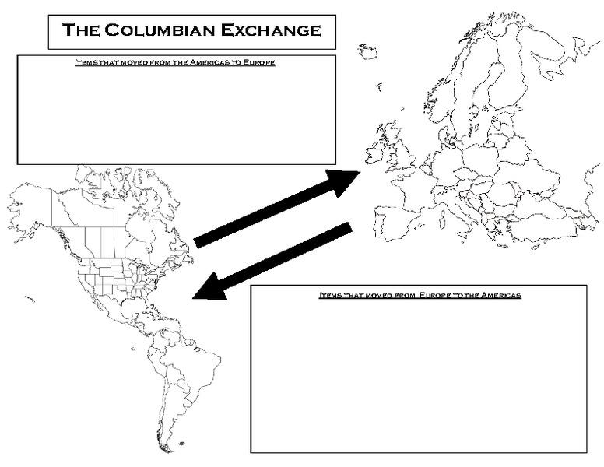
DISEASE, CITRUS FRUITS, BANANAS, RICE
BUFFALO, TOBACCO, TURKEY

Voyages of Discovery: Unit 1
2.What were the main reasons for the Voyages of Discovery? | 3.What technology helped make the voyages go further? | 4.What were the effects of the voyages of discovery on Native Americans?
WEALTH,  GLORY (PERSONAL),  GOD | COMPASS  ASTROLABE  CARAVEL (SHIP) | TRADING, DISEASE WAS SPREAD
Colonial Foundations – What area some key characteristics of how each area colonized? Unit 1
5.Northern / New England Colonies | 6.Middle Colonies | 7.Southern Colonies
MOSTLY TRADE AND SHIPPING | TRADING AND FARMING, KNOWN AS THE “BREADBASKET” COLONIES | MOSTLY FARMING, LARGE PLANTATIONS

8. The difference in the economic development of the New England, Middle, and Southern colonies resulted primarily from which of the following?
a. geographic diversity
b. customs of the immigrants
c. methods of governing the colonies
d. the extent of education in the colonies

9. Which statement most specifically sums up why the early colonists came to North America?
a. The colonists were fleeing hard times in Europe.
b. The colonists came for work and religious freedom.
c. The colonists came for adventure.
d. The colonists came to start a new life.
10. Samuel Adams and others called the confrontation between British soldiers and civilians in March of 1770 the “Boston Massacre” in order to
a. Sway public opinion against the British
b. Describe the event as truthfully as possible
c. Inspire foreign countries to support the colonies
d. Encourage Parliament to repeal the Intolerable Acts

11. Which conflict created the debt that American colonists were expected to repay to Great Britain during the 1760’s?
a. French and Indian War
b. Spanish-American War
c. Glorious Revolution
d. American Revolution

Unit 2 – American Revolution:
12. Table: What occurred on each date? (HINT: Use your American Revolution Packet-also located on our class website)
DECLARATION OF INDEPENDENCE
INTOLERABLE ACTS
INTOLERABLE ACTS
TEA ACT; BOSTON TEA PARTY
BOSTON MASSACRE
TOWNSHEND ACT
QUARTERING ACT
STAMP ACT
END OF THE FRENCH AND INDIAN WAR
BEGINNING OF THE FRENCH AND INDIAN WAR

1754

1763

1765

1765

1767

1770

1773

1774

1776

13. Mercantilism is the idea that nations could become powerful through wealth. How did this economic ideology affect England’s relationship with her North American colonies?  ENGLAND WANTED THE POWER AND WEALTH, THUS THEY TRADED WITH THE COLONIES IN ORDER TO MAKE THE MOST MONEY (THE COLONIES WOULDN’T CHARGE AS MUCH SINCE THEY WERE BRITISH) |  |  | 14.What affect does salutary neglect have on Colonial America?  ENGLAND LEFT THE COLONIES ALONE AND THE COLONIES CREATED THEIR OWN GOVERNMENT
15.In the event known as the Boston Massacre, five men died. Why is this event a “big deal?” How did it lead to the revolution?  AT THIS POINT, THE COLONISTS ARE VIEWING THE BRITISH AS THE AGGRESSORS AND ARE BEGINNING TO NOT TRUST THEM | 16.In 1773, the colonists staged a protest against the Tea Act known as the Boston Tea Party. How does England retaliate?  1. CLOSED THE HARBOR  2. BAN TOWN MEETINGS  3. INTOLERABLE ACTS  17.What do the colonists call these actions?  THE INTOLERABLE ACTS |  |  | 18. Why is Thomas Paine’s pamphlet considered an important revolutionary event?  IT HELPED TO CONVINCE AMERICANS TO OVERTHROW THE UNFAIR BRITISH GOVERNMENT
19.Even though the revolution was about many things, one of the common themes is summarized in the quote “No Taxation Without Representation.” Based on this quote, what were the colonists really protesting?  THEY WERE PROTESTING THAT THEY WERE BEIGN TAXED, BUT DID NOT “HAVE A SAY” IN THE BRITISH GOVERNMENT |  | 20.One year prior to the Declaration of Independence, the Olive Branch Petition was signed and given to the King. How is this document different from the Declaration of Independence in its intentions?  IT WAS A DOCUMENT THAT AFFIRMED AMERICAN LOYALTY TO GREAT BRITAIN

Unit 3: Constitution
21. The following list of terms in some way contributed to the shaping of US Constitution. For each term, describe in the box how each event / document contributed.

FIRST GOVERNING DOCUMENT IN THE COLONIES (SELF-GOVERNMENT)

PEOPLE DEVELOPED NEW IDEAS ABOUT THE GOVERNMENT
FIRST DOCUMENT TO LIMIT THE POWER OF THE KING

Magna Carta Enlightenment Mayflower Compact
ESTABLISHED FREEDOM OF RELIGON
ESTABLISHED FREEDOM OF SPEECH AND PRESS

FIRST ELECTED LEGISLATIVE BODY

Va. House of Burgesses John Peter Zengar Case Maryland Toleration Act
1ST WRITTEN GOVERNMENT FOR THE UNITED STATES; FAILED B/C THE NATIONAL GOVT DID NOT HAVE ENOUGH POWER
WAR FOR THE COLONISTS INDEPENDENCE
DECLARED THE COLONISTS INDEPENDENT FROM BRITAIN

Declaration of Independence American Revolution

Articles of Confederation
CURRENT WRITTEN GOVERNMENT FOR THE UNITED STATES

US Constitution

Unit 3: America experiences its first political battles:
22. State Decision-Making
Virginia Plan
New Jersey Plan

1. 2 REPRESENTATIVES PER STATES (EQUAL REPRESENTATION) 1. REPRESENTATION BASED ON POPULATION

The Connecticut Compromise

BICAMERAL (2 PART) legislature (Two-House)
SENTATE HOUSE OF REPRESENTATIVES
2 per state based on population

23. Representation and Slaves
North: END SLAVE TRADE, SLAVES ARE NOT COUNTED TOWARD REPRESENTATION
South: KEEP SLAVE TRADE, SLAVES ARE COUNTED TOWARD REPRESENTATION
Compromise: END THE SLAVE TRADE BY 1808; EVERY 3 OUT OF 5 SLAVES COUNTS AS 1 PERSON IN THE POPULATION COUNT TOWARD REPRESENTATION (3/5 COMPROMISE

24. Two groups form…

Federalists | Anti-Federalists
- WANTED A STRONG NATIONAL GOVERNMENT  - DID NOT WANT TO WORRY ABOUT IF THE NATIONAL GOVERNMENT WOULD RESPECT THE PEOPLE (DID NOT SEE A NEED FOR THE BILL OF RIGHTS) | - WANTED A SMALL NATIONAL GOVERNMENT (MOST OF POWER BELONGING TO STATES)  - WANTED A BILL OF RIGHTS

25. What compromise do the 2 groups above come to? BILL OF RIGHTS
- Bill of Rights-Directions: Write the number of the amendment on the line (1-10)
a. AMENDMENT 7 Trial by jury in civil cases over $20
b. AMENDMENT 9 Powers not named go to the people
c. AMENDMENT 3 No quartering of soldiers
d. AMENDMENT 2 Right to bear arms
e. AMENDMENT 6 Right to a speedy trial & the right to an attorney
f. AMENDMENT 4 No unreasonable search and seizure
g. AMENDMENT 1 Freedom of speech, religion, press and petition
h. AMENDMENT 5 Rights of the accused: Right against self-incrimination, no double jeopardy, “due process” of law
i. AMENDMENT 10 Powers not named go to the people and the states
j. AMENDMENT 8 No cruel and unusual punishment& no excessive bail
Principles of the US Constitution:
Principle | Explanation (what does this mean?)
27.Popular Sovereignty | IDEA THAT THE POWER LIES WITH THE PEOPLE  A
28.Limited Government | THE LAW APPLIED TO EVERYONE, EVEN THOSE WHO GOVERN (A.K.A. RULE OF LAW)
29.Checks and Balances | KEEPS EACH BRANCH FROM BECOMING TOO POWERFUL (EACH BRANCH CAN “CHECK” OR RESTRAIN THE POWER OF THE OTHERS)
30.Separation of Powers | 3 BRANCHES OF GOVERNMENT EXIST (LEGISLATIVE, EXECUTIVE, JUDICIAL)
31.Federalism | THE POWER IS SPLIT BETWEEN A NATIONAL AND A STATE GOVERNMENT
32.Judicial Review | THE SUPREME COURT HAS THE POWER TO DELCARE LAWS CONSTITUTIONAL OR UNCONSTITUTIONAL

Which principle is it? (popular sovereignty, limited government, checks & balances, separation of powers, federalism, judicial review)
- If the Congress passes a bill the president can veto the bill, then the Congress can override his veto with a 2/3 vote. CHECKS AND BALANCES

- The US Supreme Court can declare acts of the President or the Congress unconstitutional. JUDICIAL REVIEW

- The Constitution divides the federal government into three branches (legislative, executive & judicial). SEPARATION OF POWERS

- The power of the US government is derived (comes) from the people.
- POPULAR SOVEREIGNTY

- The power of the government is regulated by the people and the US Constitution LIMITED GOVERNMENT

- In the United States we have a strong national government which shares some power with lower state governments. FEDERALISM

- Which principles of the Constitution prevent all the power of the government from being in the hands of one person or one branch of government? LIMITED GOVERNMENT, SEPARATION OF POWERS, CHECKS AND BALANCES

TYPES OF POWERS: concurrent, delegated, reserved.
- The power of the states and federal government to collect taxes and build roads are an example of CONCURRENT powers.

- The power of the US Congress to declare war is an example of a DELEGATED/ENUMERATED power.

- The power of the states to establish schools is an example of a RESERVED power.

