Colonization Unit 1
The Thirteen Colonies

Part A: Regional Geography. Look at the map. Read the boxes next to the map and copy the contents into the boxes on the map. Then, fill in the boxes below.

New England Colonies
Middle Colonies
Southern
Colonies
Part B: Colonies Map. Using the map and the readings, complete the following:

1) Label the following on your map (do NOT use abbreviations, use arrows if needed):
• All 13 Colonies
• The Great Lakes
• The Appalachian Mountains
• The Atlantic Ocean

2) Shade/Color the following differently on your map:
• New England Colonies
• Middle Colonies
• Southern Colonies

3) Create a Key for #2 above.

4) Answer the following questions using the map:
a) What served as the western boundary for the Middle and Southern Colonies?

b) What country controlled the 13 Colonies?

c) Write a statement that describes the economy of each region:
• New England Colonies:

• Middle Colonies:

• Southern Colonies:

d) Which two regions seem most alike economically? Why?

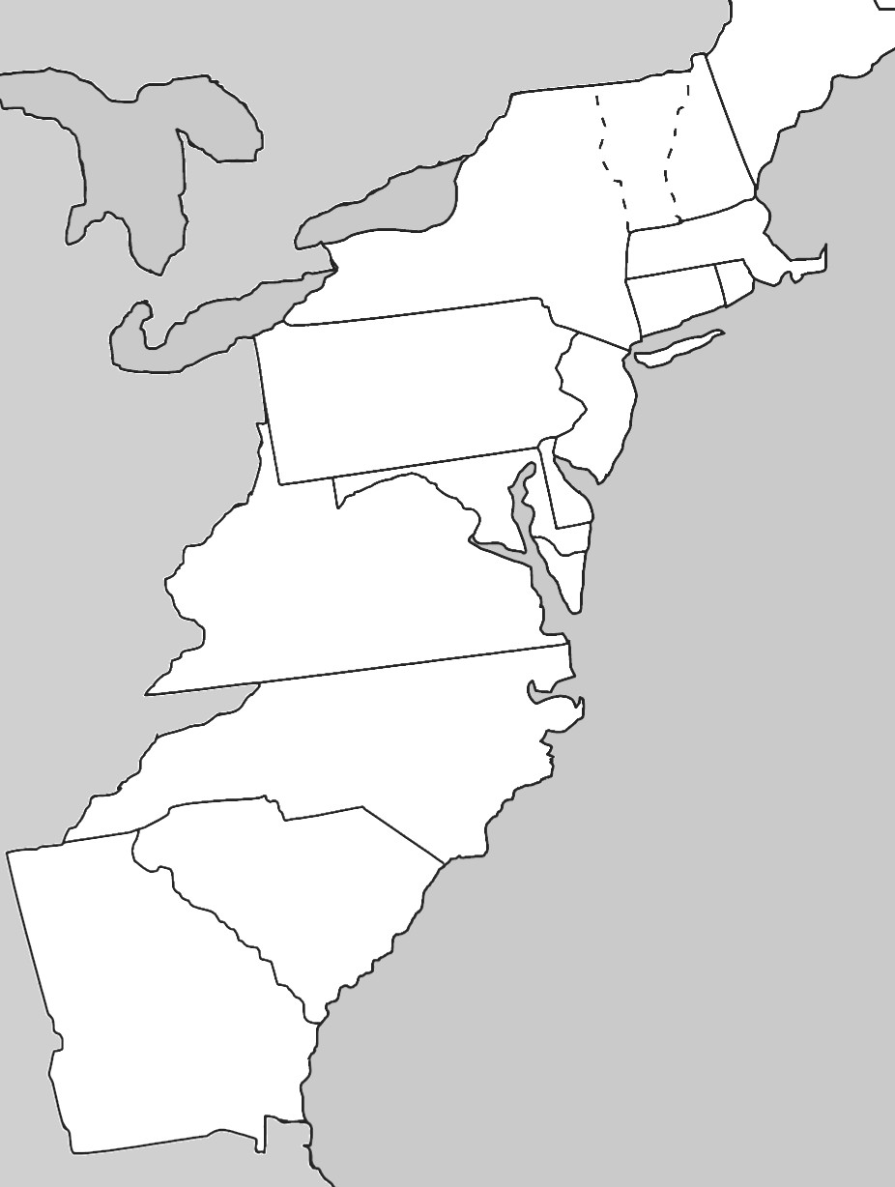
New England Colonies

Middle Colonies

Southern Colonies

